
Ivan Karpliuk
Impact of the COVID-19 Pandemic on the Airline Industry: Comparison of Actual and Expected Losses

School of Accounting and Finance
Master’s thesis in Discipline
Master's Degree Programme in Finance
Vaasa 2022

UNIVERSITY OF VAASA
School of Accounting and Finance
Author: Ivan Karpliuk
Title of the Thesis: Impact of the COVID-19 Pandemic on the Airline Industry: Comparison of Actual and Expected Losses
Degree: Master of Finance
Programme: Finance
Supervisor: Tatiana Garanina
Year: 2022 Pages: 70
ABSTRACT:
Since the day COVID-19 was declared a pandemic many companies in various industries all over the world have been affected by this fact. While some businesses have extracted profit from this situation, the airline industry, and, in particular, its passenger transportation sector, as a whole have suffered major losses due to the pandemic. As of 2022, while there have been some works published on the topic of COVID-19 and airlines, there is still not enough literature available to fully understand and evaluate the effect the pandemic had or still has on commercial airlines. Thus, this work will expand the available knowledge of this subject. Using the data from OpenSky, FlightRadar24 and Yahoo Finance we check the changes in air traffic in different parts of the world over the years, as well as how specific commercial airlines have been affected by the pandemic from the initial periods to the current moment when the majority of the counties have removed COVID-19 restrictions. As a result of our analysis, several facts have been established, such as that even in the 3rd quarter of 2022, the majority of the airlines still experience the lingering effects of the pandemic and cannot operate on the same scale, they have done before, while some small number of the commercial airlines have financially benefitted from the COVID-19 in regards of their stock prices and managed to hold this advantage till the current year.

KEYWORDS: COVID-19, airline, geo analysis, moving averages, ARIMA model, stock prices, forecasting.

Contents
Introduction 4
Chapter 1. Literature review 6
Chapter 2. Examining the changes in air traffic in different regions and globally 12
2.1. Geo Analysis and the overview of the total and commercial flight traffic 13
2.2. Results from the graphical analysis 14
Chapter 3. The Analysis of the impact of the pandemic on specific commercial airlines. 18
3.1. Sample and data collection 19
3.2. Analysis of stock prices changes 22
3.3. Observations from analyzing the stock prices of the companies and checking the hypotheses 40
Conclusions 42
References 44
Appendices 48
Appendix 1. Graphical analysis and models of the airlines from the sample not presented in Chapter 3. 48
Appendix 2. Models of the airlines presented in Chapter 3. 65

Introduction

It has been around three years since COVID-19 was discovered and quickly after that affected the world in a rather drastic way for both usual people and businesses operating in the market. While companies in certain industries have managed to use this situation to their advantage and achieve high profits, the air transportation sphere has experienced chiefly negative consequences of this pandemic, which caused major losses for the firms. Yet, nonetheless, it was unclear what is the exact damage the industry suffered and whether this damage was the same for the companies in different parts of the world.
In the previous work (Karpliuk, 2021), we have tried to answer these questions, basing our research on the initial stage of COVID-19, however, by the time the work was created, the threat of the pandemic was still far from over and airlines still faced major restrictions on their operations. Due to this reason, it was decided, that additional research is required. Thus, in this thesis, we will try to see how COVID-19 affected airline companies during the year 2021, will check if there are any major aftereffects of it on the firms operating in this sphere in 2022, and will also analyze in detail some of the findings uncovered before (Karpliuk, 2021).
The information provided in this paper can be helpful to various groups of people interested in airline performance, for instance, such groups are likely to include investors or scientific researchers. Additionally, it can also be helpful in increasing the knowledge on this subject, since even though there have been new publications appearing, containing data about COVID-19 and airlines, they mostly focus on situations in certain countries in the world, such as USA or China, while not providing the detailed data about the situation globally.
The goal of this paper is to determine the impact of COVID-19 on airline companies between the years 2019 and 2022. To achieve this goal several objectives have been selected:
- Study the information about this topic from the existing literature.
- Conduct an analysis of changes in air traffic in different parts of the world for the period, when COVID-19 was recognized as an immediate threat and for the corresponding periods in the following years.
- Explore, what impact the pandemic had on the financial situation of specific airlines over the course of 2021 and 2022.
The structure of the work contains an introduction, three chapters, conclusions, a reference list, and an appendix.
The first chapter will include a brief summary of the relevant information concerning the initial stages of COVID-19 and past crises with significant effects on airline industry, as well as the findings from the literature, published after the early stages of the pandemic, about how COVID-19 has affected aviation, and, lastly, the mention of the suitable theoretical framework to analyze the situation with airlines after the crisis started.
In the second chapter of this paper, we will first formulate the hypotheses, which we will later test to help us achieve the main research goal. After that, we will try to check how air traffic has altered in different parts of the world (conduct a geo analysis), as well as make a numerical overview of global changes to both the total and the commercial number of flights between 2019 and 2022. The results in this section will be available in their graphical representation form.
The third chapter will contain information about creating the sample of airlines, the building of the models, their results and the interpretation of the results in terms of the extent to which specific airlines have been affected by the coronavirus.
Finally, the appendix will include the extra data about the built models, which was not included in chapter 3.

Chapter 1. Literature review
As it was mentioned we will conduct a brief overview of the relevant literature published during or before the initial stages of the pandemic. According to the data, which were available by that period of time, COVID-19, after being recognized as a threat, has very drastically reduced the number of flights all over the world over the span of only one month (the traffic has decreased by 80% by early April 2020) (Pearson, 2020) and caused a couple of dozen commercial airlines to go bankrupt, even though some of them have been successfully operating on the market for decades (IAR, 2020). Additionally in 2020 commercial aviation has experienced 1) an overall reduction of 51% of seats offered by airlines, 2) a decrease in the number of passengers by approximately 2,8-2,9 billion passengers, 3) potential losses in operating revenues of around 390 billion USD (ICAO, 2020). Despite these circumstances, some authors like Stefan (2020), Czery et. al. (2020) and others have expressed their expectations of a fast industry recovery, based on the information from the previous crises (SARS, MERS, Ebola, Global economic crisis in 2008) and data about the airline performance in China during COVID-19. These opinions were later refuted by additional publications by International Civil Aviation Organization (2021) and by Belhadi et al. (2021), which mentioned, that while air transportation companies are heading towards recovery, the extent of damage to them due to travel restrictions and major job losses, it will take more than 5 years for this sphere to return to pre-crisis levels.
After we have refreshed the information from the papers, which were available at the time of the initial stages of COVID-19, we will next check some of the additional sources, which appeared afterwards, as well as mention the effects of the pandemic on airlines from the theoretical point of view.
If we were to look at the situation with airlines from the year 2020 and onward, it may be wise to use a strategy tripod theoretical framework described first by Michael Porter (1980) and later expanded by Mike W. Peng and others (2009) in their work. According to it, the factors, which can affect firms’ performances can be explored from the resource-based view, industry-based view and institution-based view.
The resource-based view claims that a firm can receive a competitive advantage, both temporary and permanent if it possesses some kinds of unique resources and capabilities. Alternatively, if a firm doesn’t have access to such, it will struggle to perform better than its market competitors.
The industry-based view is built around examining the environment in the industry. It will focus on analyzing the external circumstances in the market and will determine the possibility of gaining a competitive advantage.
Lastly, the institution-based view relies on the brief that both formal institutions, such as laws and regulations, and informal institutions, such as norms, beliefs, and ethics, can also have a significant effect on firms' performances. How quickly companies will be able to adapt to such “rules of the game” also determines whether a firm will succeed or fail in its activities (Garrido et al., 2014).
Applying this strategy tripod framework to COVID-19 and airlines, we can view the coronavirus, which is an external shock, as a sort of industrial impact, and the following restrictions regarding air traffic as an application of an institutional force, which, as we know, later led to the negative consequences for many airline companies.
After we have mentioned the situation with COVID-19 and the airline industry from the theoretical point of view, let us switch to the review of the papers published after the initial stage of COVID-19 was over.
Some of the authors have decided to dedicate their time to exploring the impact of COVID-19 on commercial airlines in specific countries or regions of the world. For instance, Fontanet-Pérez et al. (2022) in their paper provided the readers with information on how the biggest US airlines were affected in financial terms during the crisis. They found out, that all 10 airlines they selected have suffered substantial losses, yet these losses nevertheless differ significantly between companies, which corresponds to the results of our own previous research (Karpliuk, 2021). Vazquez et. al. mention, that this was caused by the fact that selected airlines used different business models. To be more specific, according to the authors of the paper, US airlines, which use Full-Service Network Carrier model suffered the highest losses, while the ones using Ultra-Low Cost business model suffered the least.
The authors of a different paper also focused on the situation with US region. Atems & Yimga (2021), have evaluated the numerical decrease in the daily commercial flights and daily passenger screening at US Airports from the moment COVID-19 had been recognized as a threat, as well as also try to model how the US airlines’ prices responded to the immediate shock of the coronavirus, as well as focusing on other immediate consequences for the airline sector in this country. For instance, they have mentioned that on top of losing a portion of wealth from the COVID-19 shock, the airlines also made massive lay-offs in the sector employment and faced high volatility in jet fuel prices.
Pérez-Campuzano et al. (2022) the authors of a different paper, using data-mining techniques, such as Self-Organizing Maps (SOMs) and K-means clustering, have reached similar conclusions to the two aforementioned articles, in terms that airlines in the US have been drastically affected from the financial point of view from the start of COVID-19.
Regarding the situation in over countries and regions, some people have also explored the impact in Asian Countries. Thus, Kim & Sohn (2022) looked at the airlines operating mainly in South Korea and found, that the impact on commercial airlines has also been devastating. To be more specific, the authors note, that in 2nd quarter of 2020, the demand for international transportation from and to South Korea dropped by 97,9%, while domestic flights reduced by 37,8%. As indicated in the graph below, according to Kim & Sohn (2022) the airlines, which focused mainly on domestic routes managed to resume their operations after some time in 2020, while the companies with a focus on the international segment had to either cease their operations completely or shift the activities towards the domestic segment.
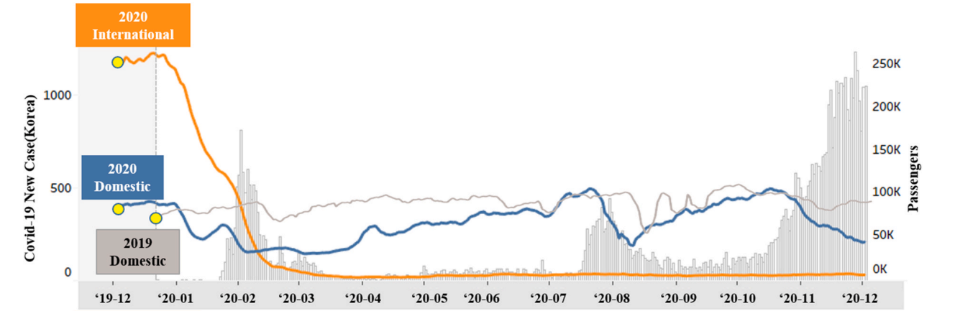
Figure 1. Number of passengers using domestic and international air transportation in South Korea. Source: Kim, M. & Sohn, J. 2022. Passenger, airline, and policy responses to the COVID-19 crisis: The case of South Korea.
Additionally, the authors have also made a brief comparison of how the demand for air transportation has changed in the initial period of COVID-19 in China, the US and Japan, compared to South Korea. They note, that while Japan immediately experienced reduced demand in this regard, and China after a very brief increase in the first 2 weeks faced a major drop later. Airlines in the USA, at the same time, still operated actively during this period, which corresponds to what we have noted in our previous paper (Karpliuk, 2021). Ng et al. (2022), researchers who also explored the impact of COVID-19 on Asian airlines have reached the conclusion, that international aircraft carriers have suffered the heaviest losses due to the impact of the coronavirus.
Finally, Scheiwiller & Zizka (2021), authors who have checked how airlines originating in the European Union responded to this unexpected crisis, provide their readers with the information, that the management of these companies also had a lot of discussion and trouble in deciding how to minimize their losses and save their clientele even in such difficult times.
Not all authors, writing about airlines during the coronavirus, have decided to focus on companies' performance in one specific region, instead, they contributed other valuable information related to the topic.
Garaus & Hudakova (2022), for example, dedicated their time to exploring the impact of the COVID-19 pandemic on tourists’ air travel intentions. They mention, that following the 52% decrease in departing flights globally since the COVID-19 outbreak, in addition to travel restrictions introduced by governments, a lot of people also decided to avoid airplanes as a method of transportation due to the perceived health risk. To address this, the airlines generally selected two possible approaches regarding the advertisement of their services: appeal to people’s emotions (with a message such as that even during COVID-19 life is still ongoing, and people should not be afraid to travel via planes) vs select “safety” advertisement (focus on explaining in detail how exactly airlines protect their clients, where it is safer to travel, etc.). Based on the results of their research, Garaus & Hudakova (2022) conclude, that the effectiveness of both approaches varied depending on the gender, age category and level of education of their clients. Nevertheless, the “safety” approach on average has proven to be more appealing to airline clients.
Compared to Garaus & Hudakova (2022), Chen et al. (2022), decided to shift their attention to how not clients, but investors perceive commercial airlines during times of crisis. In particular, they explored the assumption that environmentally-social-governance-focused airlines (ESG-focused), have been affected less by COVID-19. To check this theory, they collected the stock data of daily prices and daily returns of 4 major US airlines (Delta, American Airlines, Southwest Airlines, and United Airlines). After building the models and finishing statistical tests Chen et al. (2022) claim, that promoting ESG can reduce the volatility of airline stocks, and can indeed serve as a protection again shocks, even major ones such as COVID-19. However, it should also be noted, that while this research gives readers some interesting information, its validity should still be confirmed, since 4 airlines based in one country are not enough to derive conclusions which can be extrapolated globally.
While the majority of other authors have focused on the performance of existing airlines Sun et al. (2022) paid attention to the possibility of new commercial air transport companies. According to them, while COVID-19 dealt unprecedented damage to the industry, it has also subsequently created a vacuum, in which new airlines can appear and develop. This initial opinion was also reinforced by the following factors: 1) companies operating in the air transportation industry have historically been outperforming firms from other sectors in terms of growth rates, 2) a lot of airlines have laid off a significant amount of their workforce, which gives the opportunity to start-ups to easily acquire talented and experienced workers, 3) the sudden nature of the crisis has led to many established airlines to not being able to make quick decisions, this way further opening the path to the newcomers. Sun et al. (2022) later in their research confirm their initial opinion, by mentioning that 46 new airlines have been successfully established in different parts of the world over the course of two years. They also claim, that in order to minimize the risks and attract investors' funds, these start-ups focused mainly on providing low-cost services.
Finally, among the new literature on the topic concerning airlines and COVID-19, Mumbower (2022) have checked the secondary factors which cause airlines to leave specific markets or go bankrupt during the coronavirus and non-crisis time. Such secondary factors include flight frequencies of airlines, passenger revenue per mile, whether companies focus on long-distance, medium distance or short-distance flights, presence or absence of first and business-class seats in aircraft, conducting flights to cities with multiple airports, size of airports, etc. Using the data collected from US market, Mumbower (2022) mentions, that according to his research the importance of some of these factors has changed since the beginning of COVID-19. For example, while airlines, which transport their clients mainly to short or medium-distance destinations have a higher chance of exiting the market compared to the ones focusing on long-distance targets, during the coronavirus this factor stopped being significant (i.e. airlines had an equal chance of becoming bankrupt regardless of their usual operating distance). Simultaneously while the size of the airport hubs didn’t affect the probability of exit for the airlines before the coronavirus, it started to increase the chance with the beginning of the crisis.
As can be noticed, a number of publications on a variety of topics concerning exploring the airlines during COVID-19 have been published after the initial stages of the pandemic. However, while these publications indeed give us valuable insights about situations in the specific regions of the world or about particular types of airlines or focus on other research topics, there is still not enough research material available dedicated to the financial situation of commercial airlines globally. Due to this reason in the practical part of this paper, we will try to provide some of this “missing” information.
Chapter 2. Examining the changes in air traffic in different regions and globally
In order to help us achieve our research goal, as the first step, we will formulate several hypotheses. After that, we will expand our geo analysis from the previous stage of the work (Karpliuk, 2021). In other words, we will use a visual representation of changes in air traffic over different years between March-May since this is the period when COVID-19 was first recognized as a major threat, as well as look at the general changes regarding the number of flights globally. After achieving this objective, we will focus on exploring the situation with the specific commercial airlines and with how COVID-19 has affected them.
For our research we have formulated 3 hypotheses:
- Commercial airlines on average managed to fully recover after COVID-19 by 2022
- The airlines, which quickly strengthened their positions (within the year 2020) against the backdrop of the exit of competitors from the market, managed to hold this advantage in the following years
- Budget airlines have achieved a faster recovery from the consequences of COVID-19 compared to classical and luxury airlines.
2.1. Geo Analysis and the overview of the total and commercial flight traffic
Similar to our last paper (Karpliuk, 2021), the data for this part of our research has been collected from the OpenSky Network, which contains information about current and past air traffic all over the world. We have managed to confirm, that the information existing on this website is valid by cross-checking it with the information provided in one of the articles published by ICAO (ICAO & ADS-B Flightaware, n.d.). The air traffic changes in the years selected for our research were the same, for instance, the first major hit from the coronavirus, which cause the number of flights to rapidly decrease, according to both sources, started around 2020 while reaching even further decline in the 2 following months, meaning OpenSky dataset was a suitable source of data to conduct our research. Unfortunately, while we managed to collect the data for years from 2019 to 2021, it was impossible to receive the required information due to the changes in the policy of OpenSky, which made the data for 2022 unavailable. Since other major air traffic monitoring services, such as OAG or The International Air Transport Association (IATA) do not provide the data detailed enough for our research purposes, we will focus our geo-analysis on the years 2019, 2020 and 2021, while also later checking the general data from another global flight tracking service Flightradar24 regarding the number of total and just commercial flights in these years and in the year 2022, to see if any major changes occurred.
The data from OpenSky has been presented in a number of CSV files, where one file corresponded with one month in a specific year. Each file contained 16 variables: callsign, number, icao24, registration, typecode, origin, destination, firstseen, lastseen, day, latitude1, lonitude1, altitude1, latitude2, longitude2 and altitude2. Due to the big sizes of each of the downloaded files for further visualization, it was necessary to reduce their sizes by removing the unrequired variables and removing missing values, as well as providing some corrections to the data. The first cleaning of the files has been performed using Python since this programming language works well with large datasets (Karpov, 2021), while further data processing steps, including the calculations of newly required parameters, have been done in RStudio using dplyr and data.table packages, plus their dependent packages, such as lifecycle, rlang, rtools, etc. In addition, to this extra information regarding the precise locations of airports worldwide has been added from another dataset, which originated from GitHub. Finally, for a clearer representation and analysis of the results we will receive, we have also limited datasets to the top 500 airports based on the total number of flights originating from each of the airports.
For the visualization of received data, we continued using RStudio with packages ggplot2 and maps. With it, we have managed to create visual representations of air traffic in different parts of the world, where the size of each point representing a specific airport on the map would indicate the total number of flights there.
Regarding the data from Flightradar24, since the file received from this source contained less information, it was decided to do both data processing (checking for the missing values, calculating moving averages to later better see trends, etc.) and visualization in Excel.
2.2. Results from the graphical analysis
Using the methods mentioned in the previous section we have been able to create 3 geo graphs, each representing the air traffic in 500 major airports between March-May for the years 2019 (figure 2, depicted in the orange color scheme), 2020 (figure 3, depicted in the blue color scheme) and 2021 (figure 4, depicted in the green color scheme) respectively. These graphs are presented below.

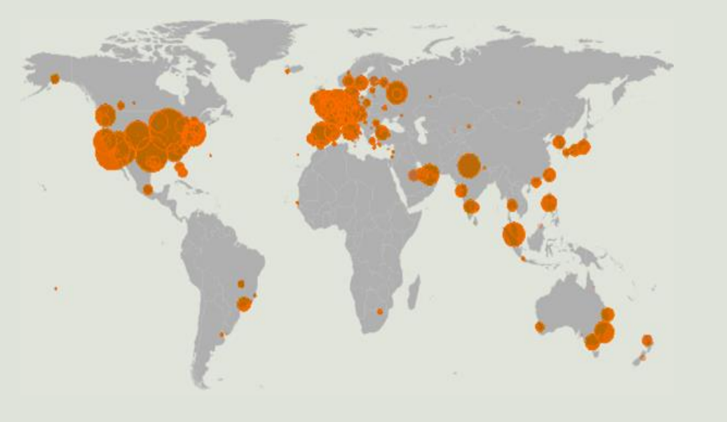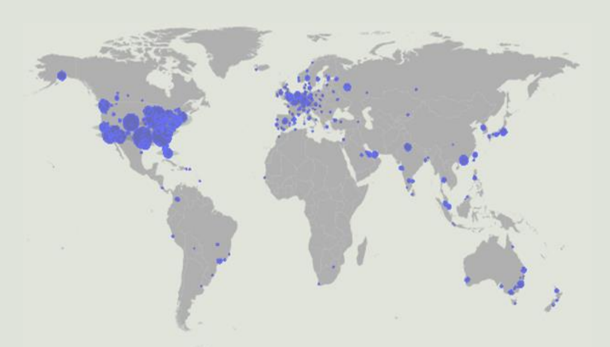
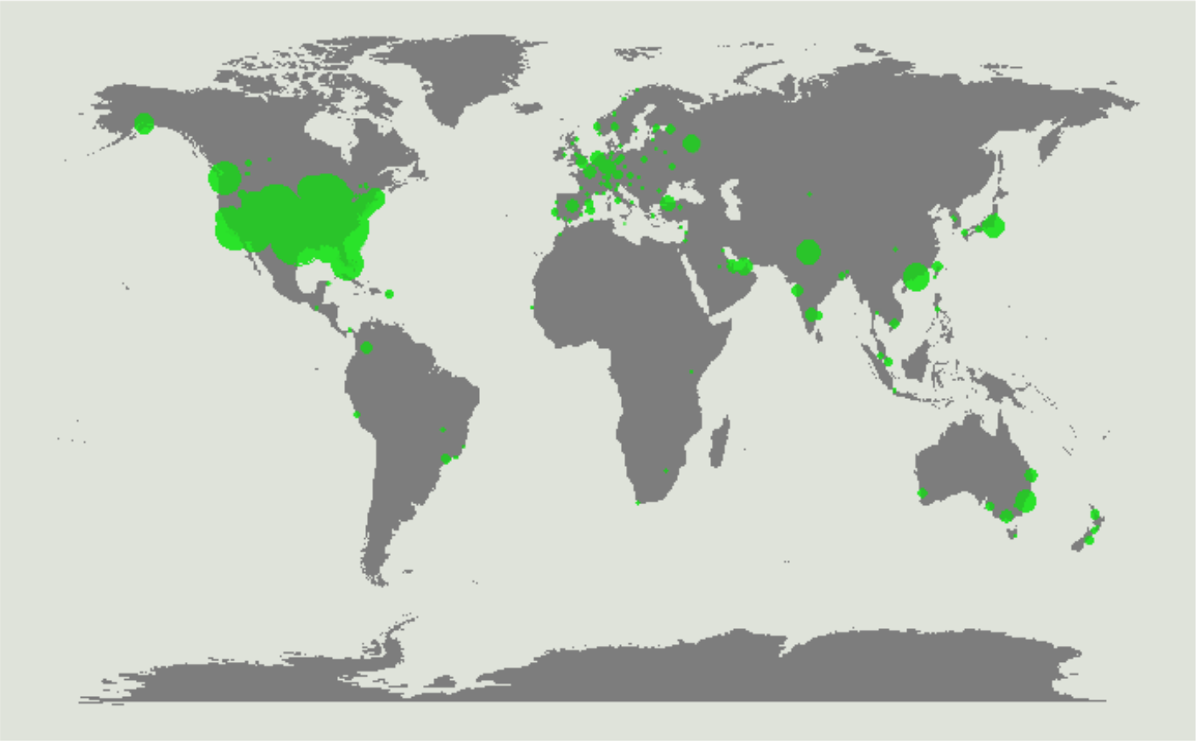
Figure 2,3,4. The Geo Analysis of the changes in the air traffic of the top 500 airports due to the pandemic in March-May 2019, March-May 2020 and March-May 2021. Source: own research.
If we look at Figure 2, it can be noticed, that before COVID-19 most of the airline activity was focused in 3 locations in descending order: Europe, North America and Asia. As depicted in Figure 3, following the announcement of the coronavirus, as a pandemic by the World Health Organization, the number of flights dropped sharply in all parts of the world, except for North America, where the decrease was much less severe. In our past research (Karpliuk, 2021), we established, that this “North America anomaly” happened because the USA prohibited international flights only in April 2020 (while other countries in the world did the same around the beginning-middle of March 2020), and even after the closure of international air travel routes from the US, domestic flights continued to operate as normal at this location. In 2021 COVID-19 vaccines started to be widely distributed in different parts of the world, thus it was possible to assume the rapid recovery of aviation. If we look at Figure 4, however, it can be noted, that such recovery happened only in some regions. To be more specific, while there is a rapid growth in air traffic activity in North America and little increase in certain parts of Asia (In China, India and Japan) in the selected period in 2021, in other locations, for instance, in Europe situation remained unchanged or even deteriorated compared to March-May in 2020. Upon, further inspection of the reasons, why this disbalance has occurred, we have established, that European and many other countries in the world either still kept their borders open only for a very limited number of people to pass through. Speaking about European countries, one of the examples of such semi-closed borders can be Norway, where till the middle of 2021 entry was allowed only for people who are planning to work in the spheres important for the country, students of some programs, people requiring immediate medical attention and other similar reasons (Norwegian Border Guard, n.d.)
The USA, at the same time, was having such a high amount of flights to and from their airports partially due to the “North America anomaly” from 2020 and partially, because of the fact, that some of its states started to open borders for tourists and other travelers earlier than other parts of the world. For instance, the officials in Massachusetts state, which already had light travel restrictions, decided to lift nearly all of the remaining restrictions in May 2021 (Dialynn, 2021).
After checking the situations, with air traffic in specific parts of the world, we will also check the overall changes in the total number of flights and number of commercial flights. Below, you can see the graphs representing the moving averages of the aforementioned values for the years 2019 to 2022. As was briefly mentioned, it was decided to use weekly moving averages instead of a standard daily flight number to be able to better see the trends in air traffic over the selected periods.
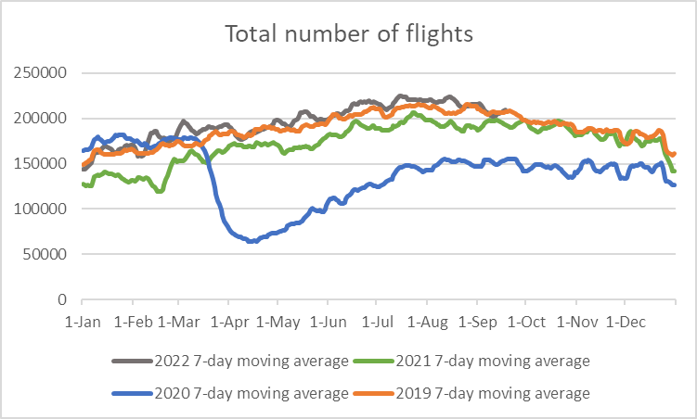
Figure 5. Total number of flights in the world for the years 2019, 2020, 2021 and 2022. Source: own research, data derived from FlightRadar24.

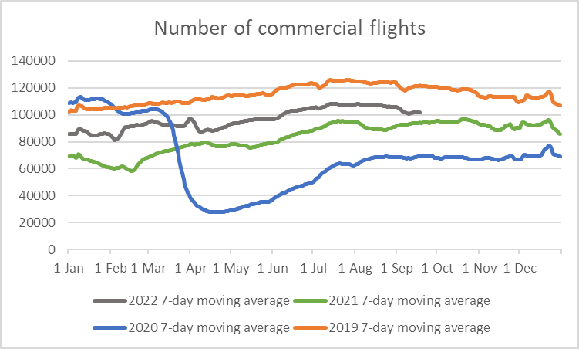
Figure 6. Number of commercial flights in the world for the years 2019, 2020, 2021 and 2022. Source: own research, data derived from FlightRadar24.

Analyzing the two graphs, we can easily notice, that after the major drop in 2020 during the initial stages of COVID-19, the number of flights quickly started to rise from the start of June to the end of August this year. After that, air traffic remained relatively stable, with some decrease around what can be considered the third wave of COVID-19 (i.e. the end of 2020, beginning of 2021). After this period air traffic continues its gradual growth in 2021. During the later part of 2021 and, in particular during 2022, we can detect an interesting fact by looking at the total number of flights and the number of commercial flights. To be more specific, while the total number of flights all over the world during these periods sometimes reaches or even becomes higher than the respective number in 2019 (i.e. before the crisis), the same cannot be said for commercial flights. Their moving averages indicate, that even in 2022, the commercial flight traffic is still around 20% lower, than in 2019. It can be explained, by the damage commercial airlines received because of the pandemic, such as the fact, that various air passenger carriers went out of business or conducted lay-offs of some of their employees.
Due to this we can conclude that the hypothesis #1 can not be confirmed - commercial airlines had shown a remarkable recovery, but they haven’t managed to operate in 2022 on the same scale as before COVID-19.
Chapter 3. The Analysis of the impact of the pandemic on specific commercial airlines.
After we have managed to check the situation with the air traffic in different parts of the world and additionally the changes to its total volume and the volume, which is only comprised of commercial flights, we will conduct the evaluation of COVID-19 impact on the specific commercial airlines.
The method which is going to be used is the analysis of the stock prices of the selected airlines. Similar to our previous work (Karpliuk, 2021), we will check the situation with how actual stock prices of commercial airlines were moving in the last several years and will make a prediction, of how these prices were likely to behave in the event that the industry would not face the crisis, in other words in the hypothetical situation without COVID-19. By checking the deviation between actual stock prices and predicted ones we will be able to see how much damage in the financial terms the coronavirus has caused in the initial period, but more importantly we will also be able to check the situation during the later stages of COVID-19 and see how fast the airlines managed to recover (if applicable to the selected airlines) and, lastly, if there are any significant everlasting effects from the crisis on these airlines by the current moment.
3.1. Sample and data collection
Since, in addition, to the evaluation of the impact of COVID-19 on specific commercial airlines, one of our hypotheses is to check whether airlines which benefitted due to the pandemic have managed to hold the advantage they received after the initial stage of COVID-19 in the next years, we will use the expanded sample of 40 airlines, over the time span of 13 years (2010-2022).
Considering we plan to include in our analysis both airlines from our previous work (Karpliuk, 2021), which we have concluded to be fortunate due to the aforementioned fact, and airlines we haven’t explored before, the criteria for the airlines in the sample will be the following:
- The airlines in the sample can only be public companies.
- The selected firms should have operated on the market for 2 or more years.
- The selected airlines can only be commercial, and the main focus of their operation must be the transfer of passengers and not the cargo delivery.
- The airlines in the sample should still be operating on the market and trading their stock as of 2022.
- The selected airlines should together make a diversified sample. In other words, the airlines should be from various countries in the world and have different volumes of operating activity.
The airlines presented in the table below have been chosen for the sample.
Air France-KLM | China Airlines | Delta Airlines | Korean Air | China Eastern Airlines
Qantas | Finnair | American Airlines | Cathay Pacific Airways | Japan Airlines
Turkish Airlines | Air Canada | Aegean Airlines | Lufthansa | Singapore Airlines
Air New Zealand | EVA Air | Copa Airlines | Southwest Airlines | Ryanair
Air Arabia | LATAM Airlines | Jin Air | EL AL | IndiGo
Alliance Aviation Services | Gol Transportes Aéreos | Wizz Air | Hawaiian Airlines | Alaska Airlines
Allegiant Air | Azul Airlines | Pegasus Airlines | Controladora | JetBlue Airways
Enter Air | Cebu Air | Spirit Airlines | Iceland Air | SkyWest
Figure 7. Sample of the commercial airlines.
The stock price data for the selected airlines have been derived from Yahoo Finance for the aforementioned period (years from 2010 to 2022). For the companies, which have started operating on the market after 2010 the period was selected accordingly. The stock price data for the airlines have been downloaded in their main trading currency (for example, Delta Airlines - in USD, EL AL - in ISL, Pegasus Airlines - in TRY, etc.). This choice has been made, in order to easier determine the impact of the pandemic on stock prices, and avoid the changes caused by fluctuations in exchange rates between currencies, which became especially unstable in the last several years.
Additionally, all of the airlines from the sample will be divided into 4 groups depending on the alliance they are a part of: SkyTeam, Oneworld, Star Alliance or no alliance. The airlines, which do not belong to any of the three major alliances, but instead belong to a smaller alliance, for instance, to the Value alliance, will be considered as a part of group 4.
After downloading the required stock price data from the source in the form of multiple CSV files, the next part, which includes prediction and analysis of the stock prices of the selected firms, will be completed in the R environment, since this programming language provides a broad and convenient array of tools for these purposes (Jishag et al., 2019). The packages used for it in the R environment are “dplyr”, “ggplot2”, “xts”, “zoo”, “timeDate”, “TTR”, “timeSeries”, “quantmod”, “forecast” and “tseries”.
We will predict the possible stock prices, for the hypothetical event of the world not encountering a crisis in the form of the pandemic, using the autoregressive moving average model (ARIMA). This method has been selected since ARIMA models are a reliable technique that can compete favourably with other alternative methods for stock price prediction (Ariyo et al., 2014). The best parameters for the models will be determined automatically by the RStudio with the usage of the “auto.arima” function. The selection can be done using as a basis either the Akaike information criterion (AIC), Bayesian information criterion (BIC) or corrected Akaike information criterion (AICc). Generally, the most suitable parameters for each specific case would be the same regardless of which of the three criteria above have been chosen, but in cases when there will be a discrepancy in the parameters we will use the 3rd criterion as the decisive one, since the corrected Akaike information criterion while having all of the benefits of “classical” AIC, it can also avoid the problem of the potential model overfitting for the cases when the sample size is insufficient.
In the following part of the work, we will include a brief overview of 3 major alliances, which form the aforementioned groups of airlines in our sample, and graphical representations comparing the predicted stock prices (for the scenario without COVID-19) with their real counterparts for selected firms. For readers’ convenience, this section will contain such data for only several airlines per each of the four groups. The information concerning the airlines, which will not be included in this section, but are a part of the total sample, as well as the data about models’ parameters, criterion values, and other trivia can be accessed in the Appendix section of this work.
3.2. Analysis of stock prices changes
SkyTeam
The first group of companies in our sample are a part of the SkyTeam Alliance. Out of all 3 mentioned alliances, SkyTeam was established the latest in the year 2000. Nevertheless, despite this fact, SkyTeam managed to quickly obtain the status of one of the major alliances, which operates in Europe, North and South America, Asia, Australia and Africa. The headquarters of the alliance are located in Europe. Prior to the COVID-19 crisis, the SkyTeam alliance was comprised of 19 airlines and held around 19% of the global air travel market. After the start of the coronavirus pandemic, this alliance was struck hard, when 2 of its members Alitalia and Garuda Indonesia, which are both flagman commercial airline companies of Italy and Indonesia, became bankrupt. The analysis of the impact of the pandemic on some of its other members regarding their respective stock price values is presented below.
Air France-KLM
Air France-KLM is one of the commercial air transportation groups, which consists of 2 European air passenger carriers (Air France and KLM). It was established in 2004 and started operating globally since then. Before the crisis, it was considered the biggest airline regarding its revenue and 3rd biggest regarding its fleet capacity. Due to these properties, it is considered one of the “pillars” of the SkyTeam alliance.

Figure 8. Stock prices for Air France-KLM. Source: Yahoo Finance and own calculations.
Looking at the graph above we can notice that the stock values of Air France-KLM have been historically quite volatile. The model has predicted, that without the crisis the company stock values would still drop in 2020 but will slightly rise in the following years 2021 and 2022. Following the start of the pandemic, however, the stock price values dropped by almost 70%, indicating how seriously the airline has been affected by COVID-19. While it has shown a sign of rapid recovery in the 4th quarter of the year 2020, in the years 2021 and 2022, the company stock prices were reduced even further to around 15% of their pre-crisis values. Due to these facts, we can expect that even if the company manages to recover in the future, it will take prolonged periods of time.
China Airlines
China Airlines is one of the leading air transportation companies, located in Taiwan. It provides services to its customers on a global scale for several decades as of now.

Figure 9. Stock prices for China Airlines. Source: Yahoo Finance and own calculations.
From the graph depicting the stock prices of China airlines, we can notice several things. For instance, there were only 2 points between the years 2010 and 2019 when the stock prices of the company had high volatility, while on average, the stock prices haven’t changed significantly during these years. Due to this pattern, the model has predicted, that in the scenario without the crisis the stock values will remain largely unchanged. Moreover, despite COVID-19 and the restrictions on air travels caused by it, the company stock price values haven’t been affected negatively too much during the initial stage. At the same time, starting from the end of 2020, China Airlines managed in the span of 1 year to increase its stock price by more than 3 times its respective values from 2019, indicating that the company is likely to have benefitted a lot from the pandemic situation, compared to its competitors.
Delta Airlines
Delta Airlines is an American air passenger carrier company, which is based in the USA. It is one of the oldest airlines, with its foundation date in the year 1924, and it is also one of the airline companies which have created the SkyTeam alliance. In the modern world, the company operates on a global scale and is considered the largest company based on its fleet size, the number of airports it travels to and from and the total number of passengers transferred.

Figure 10. Stock prices for Delta Airlines. Source: Yahoo Finance and own calculations.
Before the crisis, Delta Airlines has shown a steady and continuous growth rate of its stock prices and under these circumstances, as shown by the predicted values, was supposed to follow the same trend in the future. However, after COVID-19 has been declared a pandemic, the firm quickly lost more than 50% of its stock value. Following the initial stage of the coronavirus, Delta Airlines started to recover, however, in 2021 and subsequently, in 2022 the company stock value growth rate on average has been negative, indicating the severe damage the company has suffered because of COVID-19.
Korean Air
Korean Air is another commercial airline, which was a part of the SkyTeam alliance foundation. This company is a flagman air passenger transportation company of South Korea, operating on the market since 1962.

Figure 11. Stock prices for Korean Air. Source: Yahoo Finance and own calculations.
According to the graph, Korean Air also suffered a major drop in its stock values around March-April of 2020. While showing no signs of recovery during the 2nd and 3rd quarters of the same year, the company managed to reach its pre-crisis levels and outperform the prediction in 2021. After that, the stock prices of the company have remained largely unchanged at the same levels, potentially showing that the airline does not experience a significant long-lasting impact from the pandemic.
Oneworld
The second group of companies in our sample cooperate with the Oneworld alliance. Oneworld was created in 1999 and currently has 12 members, with the headquarters located in the USA. Before the pandemic, the members of this alliance operated in 158 countries located in Europe, North and South America, and Australia, and the alliance was responsible for around 15% of commercial passenger transportation in the world. While none of the members of the alliance has left the alliance due to the bankruptcy caused by COVID-19, one of its key members – LATAM Airlines, which is a major south American air passenger carrier, left the alliance in the year 2020 after receiving the investment offer from the member of another alliance – Delta Airlines. The stock price analysis of several of the members of the Oneworld alliance from the sample is presented below.
Qantas
Qantas is a flag carrier of Australia, which provides passengers from this continent with travel services to 85 locations all over the world for several decades. It is one of the founders of the Oneworld Alliance.

Figure 12. Stock prices for Qantas. Source: Yahoo Finance and own calculations.
It can be noticed that the past performances of the airline’s stock values, while not being the most stable, followed the upward trend. Nevertheless, the initial hit of the pandemic caused these values to drop by more than 2 times suggesting the high damage from the pandemic, and while the stock prices of Qantas have shown signs of rising by the beginning of the 3rd quarter of 2020, in the next 2 years, the speed of recovery has been slow, leading to this airline not being able to return to pre-crisis performance levels by the current moment.
Finnair
Finnair is the Finnish commercial and biggest airline in the country, which travels to 132 destinations in different parts of the world. It has been conducting its services since 1923.

Figure 13. Stock prices for Finnair. Source: Yahoo Finance and own calculations.
By analyzing the graph of the stock prices of Finnair, it can be quickly determined, that the airline has experienced major financial difficulties since the pandemic started. Its stock values have dropped by more than 80% in the span of 3 months. Furthermore, after the initial hit of COVID-19, the airline has not shown any signs of recovery in this aspect since then. Due to these 2 facts, the probability of the company resuming its activities at the pre-crisis levels is small and the future financial performance of the company is likely to stay at a low level for several more years to come.
American Airlines
American Airlines is one of the major commercial airlines of the USA, and before the crisis was considered to be the biggest airline worldwide in regard to its fleet capacity and the number of locations served. It exists on the market since 1930.

Figure 14. Stock prices for American Airlines. Source: Yahoo Finance and own calculations.
From the graph above it is possible to notice, that the airline has been having some financial problems in the years even before the crisis since the growth rate of its stock price values between 2017 and 2019 has been on average negative. If analyze the time period after the pandemic started and to the current date, we can also mention that the situation with stock prices of America Airlines is rather similar to another US Airline – Delta Airlines. To be more specific, it experienced a significant drop in the first months, and while it started to recover relatively quickly in the same year, between 2021 and 2022, the trend related to the changes in the stock prices of the company on average has been also negative, potentially signalling of the lingering effects the initial hit of the pandemic has on the airline.
Japan Airlines
Japan Airlines is the flagman commercial airline in Japan, which conducts domestic and international flights to many countries in the world for several decades, with the exceptions of the ones located in Africa and South America.

Figure 15. Stock prices for Japan Airlines. Source: Yahoo Finance and own calculations.
Apart from the period between 2010 and the 2nd quarter of 2012, when the company temporarily stopped trading its stocks, the growth rates for its values have been positive on average, and according to the model, the company stock prices were expected to rise even further, if the world did not encounter the pandemic. However, after the start of COVID-19, the company’s stock prices have dropped by around 40% of their respective values from 2019. In the following months, we can notice, that the company was on the path to recovery, and even though Japan Airlines experienced another drop in its stock prices around 3rd quarter of 2021, the values have continued to steadily increase, demonstrating, that the airline is likely to return to pre-crisis levels in the future.
Star Alliance
Star Alliance is the alliance which includes the airlines from group 3 in our sample. This is the oldest and at the same time the biggest existing alliance of the 3 major ones. It was established in 1997 with its headquarters located in Europe. The members of the alliance offer their clients air transportation services to airports from the regions of Europe, North and South America, Asia, Australia, and Africa. Prior to the pandemic, this alliance was responsible for 25% of commercial air traffic. Despite having 26 airline companies as members of the alliance, which is a larger number compared to SkyTeam or Oneworld Alliance, from the start of the pandemic, none of these airlines has left the alliance due to bankruptcy or other reasons. The impact of COVID-19 on some of the members of the alliance from the sample will be examined in the section below.
Turkish Airlines
Turkish Airlines is one of the key airlines of the Republic of Turkey. Established in 1933, it conducts air transportation on both domestic and international routes. While Turkey Airlines is not a budget airline, it has become quite famous for its customers by providing its services for a lower fee than its competitors.

Figure 16. Stock prices for Turkish Airlines. Source: Yahoo Finance and own calculations.
Analyzing the change in the stock prices of the company, it can be noted that while the company also suffered during the initial hit of the pandemic (the values dropped by around 30%), the airline managed to quickly start operating on only slightly reduced levels compared to its pre-crisis performance. Moreover, while it took Turkish Airlines a year longer than some other airlines from the sample, such as, for instance, China Airlines or EVA Air, it has managed to outperform the prediction and, furthermore, increase its stock price values by around 5 times in 2022. Such outstanding performance in this regard is likely caused by the policy of the airline, when it started to actively provide cheap tickets for customers, when COVID-19 restrictions in the world were severely reduced (i.e. in 2022).
Aegean Airlines
Aegean Airlines is the airline company of Greece, established 3 decades ago. Initially, the company was operating only on domestic routes and only much later it started conducting international passenger transfers to and from Europe and the Middle East.

Figure 17. Stock prices for Aegean Airlines. Source: Yahoo Finance and own calculations.
For Aegean Airlines the model predicted a positive growth rate for its stock prices for the years after 2019 (in no COVID-19 scenario), however, as it can be determined from the graph, the pandemic has caused severe damage to the airline. Compared to other airlines, Aegean Airlines has experienced 2 major value drops: 1st around March 2020, while the second happened a month later in the 2nd quarter of 2020. After this period the company stock prices started a quick return to their pre-crisis levels, but such a trend stopped between the 2nd and 3rd quarter of the year 2021 and prices remained on average unchanged till the current date. Due to this, we can assume, that for the company to achieve the same performance in this regard as in the year 2019 will take at least several more years.
Singapore Airlines
Singapore Airlines is a commercial airline, which focuses its business model on providing high-quality air transportation services to its customers for higher fees, than the other airlines on the market. It was created in the year 1947, and nowadays it conducts flights on both domestic and international routes.

Figure 18. Stock prices for Singapore Airlines. Source: Yahoo Finance and own calculations.
According to the received data, the stock prices of this airline, based on past performance, were expected to be relatively stable, with a slight increase at the beginning of 2020. Due to the impact of COVID-19, the company lost 60% of its stock price value by June 2020. After that the company managed to slightly recover, by the 2nd quarter of 2021, however, since the company stock price has not risen since that moment, it can be assumed, that the impact of the pandemic was too significant for this airline, and thus, the probability of returning to pre-crisis levels quickly is rather low.
Copa Airlines
Compañía Panameña de Aviación, or Copa Airlines is a commercial airline based in Panama, which has operated on the market since 1947. The company acts as an air passenger carrier in North, South and Central America and the Caribbean.

Figure 19. Stock prices for Copa Airlines. Source: Yahoo Finance and own calculations.
Based on the stock price movements of the company, it can be noted that even though the company has experienced a significant performance drop caused by the pandemic and the following restrictions, the company has also shown a high recovery rate, by almost reaching predicted values in the 1st quarter of the years 2021. Nevertheless, despite this fact in the following time periods till the current date the company stock price values have not risen significantly, indicating some similarity in this regard between Copa Airlines, and for instance, Aegean Airlines.
No alliance/minor alliances
Our final group number 4 is composed of the airlines which are not a part of either SkyTeam, Oneworld or Star Alliance. Since joining any of these 3 main alliances is a rather expensive decision for airlines, plus, considering these alliances generally have steep conditions, which airlines need to satisfy before being accepted, only a limited number of major air passenger carriers are a part of them. Other airlines, including the recently created ones, choose instead to join one of the minor alliances or operate independently. The analysis of the impact of the pandemic on some of such airlines from our sample is presented below.
Wizz Air
Wizz Air is a Hungarian commercial low-cost airline. It was established in 2003, and it focuses its operation only on the flights within the European sector.

Figure 20. Stock prices for Wizz Air. Source: Yahoo Finance and own calculations.
From the graph above, it can be noted, that even though Wizz Air, was one of the airlines, the stock values of which have been reduced significantly after the announcement of the COVID-19 pandemic, the company’s stock prices have shown a rapid recovery rate. To be more specific, the stock price values of this airline have managed to reach and outperform both the predicted numbers and the levels before the pandemic within the year. This has likely happened due to the fact, that the airline has managed to quickly adapt its strategy to the “new” conditions under the COVID-19 influence.
Allegiant Air
Allegiant Air is also a budget airline operating on the market for 2 decades. The business model of this company is focused on passenger air transfer purely on domestic routes within the United States.

Figure 21. Stock prices for Allegiant Air. Source: Yahoo Finance and own calculations.
Based on past performances the model has predicted a positive trend for the stock prices of Allegiant Air. The impact of the pandemic has caused the loss of more than 50% of the respective values. Similar to some of the other airlines in the sample, such as, for instance, China Airlines, Allegiant Air has managed to raise its stock prices significantly above the predicted and pre-crisis values, indicating, that this airline has likely benefitted from the limited competition situation created by the pandemic. At the same time, we can also notice, that this rise was only transient, considering the respective values dropped rapidly again starting from the 2nd quarter of the year 2021.
Alaska Airlines
Alaska Airlines is a company, which is based in the USA and is conducting its flight operations from the ear 1932 between countries located in North, Central and South America.

Figure 22. Stock prices for Alaska Airlines. Source: Yahoo Finance and own calculations.
Due to the COVID-19 pandemic, the stock prices of this airline have dropped to 40% of their pre-crisis values. Despite that, the company started to recover during the second half of 2020 and the beginning of 2021. While around this period Alaska Airlines managed to rise its stock price to the values of 2019, similar to Allegiant Air and other airline companies in the US, its stock values dropped in the following months.
Air Arabia
Air Arabia is a low-cost airline located in the United Arab Emirates. It was founded in the year 2003 and transports its clients between countries located in Europe, Asia, the Middle East and North Africa.

Figure 23. Stock prices for Air Arabia Source: Yahoo Finance and own calculations.
By analyzing the stock prices of this company, it can be mentioned, that before COVID-19 the values remained relatively same level, with only 2 points in time (2nd quarter of the year 2013 and the period just before the pandemic), when it showed an upward trend, because of that the model has predicted, that without external shocks, the stock prices of Air Arabia will remain stable in between 2020 and 2022, with a slight increase in the beginning. After the initial impact of the pandemic, which has caused the drop of respective values by almost 60%, the company immediately started to recover at a slow but steady pace. While the stock prices of the airline have reached both pre-crisis and predicted values and outperformed them, it happened only in the 1st quarter of the year 2022, signalling that even though this company has likely managed to adapt its strategy to the COVID-19 situation, the initial hit of the pandemic has caused major financial damage to the firm, which has lingered for several years.
3.3. Observations from analyzing the stock prices of the companies and checking the hypotheses
According to the data we have received after conducting the stock price analysis of the airlines presented in the section above, as well as the airlines, information about which is presented in the Appendix section, several observations were made.
Firstly, while many of the airlines from the sample have indeed shown signs of recovery in the year 2020 or 2021, only a very limited number of air passenger carriers have achieved the same level of performance, as they had prior to the crisis in the form of the pandemic by the year 2022. This further reinforces the conclusions, we have received after conducting the “geo analysis” and the overview of global air traffic, that the hypothesis #1 should be rejected.
Secondly, 7 of the airlines (Allegiant Air, Alliance Aviation Services, China Airlines, Controladora, IndiGo, Ryanair and Wizz Air) from our sample have achieved higher stock prices than their pre-crisis/predicted level within the year 2020, which may imply that they have benefitted from the limited competition on the market caused by COVID-19. According to the theoretical framework of the strategy tripod, it may also indicate, that these airlines have adapted their business strategy rapidly to the external shock in the form of COVID-19, and thus financially benefitted from it. Upon further inspection, the majority of these companies have managed to keep this advantage in terms of their stock price values to the current day, meaning that the hypothesis #2 should be confirmed.
Thirdly, while this is not applicable for every single airline in the sample, on average, companies which have chosen to operate as low-cost airlines, have shown a faster and greater recovery in terms of their stock prices, proving that the hypothesis #3 can be confirmed.
Lastly, despite the individual differences in the performances of each specific airline in the sample, there are certain trends in regard to how the stock prices of the companies from different countries/regions are moving during the pandemic. For instance, many of the airlines located in North America or nearby regions after a significant recovery near the end of the year 2020, appear to experience a major drop in their respective stock price values by the end of the 1st quarter of 2021, while the same pattern on average is not present for the airline companies from the European or Asian regions.
Conclusions
To summarize the findings in this paper, we succeeded in getting information about how COVID-19 have affected commercial airlines all over the world from its initial hit to the current moment in the year 2022, thus, accomplishing our selected research goal and set objectives. The aforementioned information and gained insights are likely to be helpful in expanding the knowledge on the subject, which has not been fully explored yet due to constant developments and can also serve as a basis point for further research in case the world will ever encounter another health pandemic, which will have the ability to affect air transportation industry.
At the same time, when using the data from this paper it is important to consider some of the limitations, such as:
- For the 3rd chapter of the paper, we have focused on the evaluation of the impact of the pandemic between the years 2019 and 2022 for public airlines only, which have been operating on the market for several years at least, meaning the losses and potential future gains of the private air passenger carriers and “start-up” airlines have not been discussed.
- Since the airline industry is highly seasonal, meaning the profit of the airlines fluctuates significantly depending on the time of the year, the analysis of how much COVID-19 has affected air traffic in specific parts of the world has been conducted using the periods corresponding to the initial major hit of the pandemic (i.e. months between March and May).
- While, as of the year 2022, the level of threat of COVID-19 is considered to be smaller than in the year 2020, and, thus it is unlikely, that the pandemic will have significant effects on the explored industry in the future, the possibility of unexpected developments in this regard still exists.
The limitations of this paper can be overcome by primarily checking if there will be any major news regarding COVID-19 in the following years. Moreover, it is also possible to conduct another research on the topic with a focus purely on private airline companies or to expand the knowledge about the financial performance of airlines, which have been created during or just before the pandemic, a topic which is also not fully explored.

References
Ariyo, A. A., Adewumi, A. O., & Ayo, C. K. (2014). Stock price prediction using the Arima model. 2014 UKSim-AMSS 16th International Conference on Computer Modelling and Simulation. https://doi.org/10.1109/uksim.2014.67
Atems, B., & Yimga, J. (2021). Quantifying the impact of the COVID-19 pandemic on US Airline Stock prices. Journal of Air Transport Management, 97, 102141. https://doi.org/10.1016/j.jairtraman.2021.102141
Belhadi, A., Sachin K., Jabbour C., Gunasekakaran A., Ndubisi N., & Venkatesh M. (2021), “Manufacturing and service supply chain resilience to the COVID-19 outbreak: Lessons learned from the automobile and airline industries”, Technological Forecasting and Social Change, vol. 163.
Chen, C.-D., Su, C.-H. (J., & Chen, M.-H. (2022). Understanding how ESG-focused airlines reduce the impact of the COVID-19 pandemic on Stock returns. Journal of Air Transport Management, 102, 102229. https://doi.org/10.1016/j.jairtraman.2022.102229
Czerny, A. I., Fu, X., Lei, Z., & Oum, T. H. (2021), “Post pandemic aviation market recovery: Experience and lessons from China”, Journal of Air Transport Management, vol. 90.
Dialynn, D. (2021, May 20). The US is lifting COVID-19 restrictions too quickly. Boston.com. Retrieved August 27, 2022, from https://www.boston.com/news/coronavirus/2021/05/20/jonathan-levy-concerns-massachusetts-lifting-coronavirus-restrictions/
Flightradar24, Live Flight Tracker - Real-Time Flight Tracker Map. Flightradar24. Available at: https://www.flightradar24.com/ [Accessed September 17, 2022].
Fontanet-Pérez, P., Vázquez, X. H., & Carou, D. (2022). The impact of the COVID-19 crisis on the US airline market: Are current business models equipped for upcoming changes in the Air Transport Sector? Case Studies on Transport Policy, 10(1), 647–656. https://doi.org/10.1016/j.cstp.2022.01.025
Garaus, M., & Hudáková, M. (2022). The impact of the COVID-19 pandemic on tourists’ air travel intentions: The role of perceived health risk and trust in the airline. Journal of Air Transport Management, 103, 102249. https://doi.org/10.1016/j.jairtraman.2022.102249
Garrido, E., Gomez, J., Maicas, J. P., & Orcos, R. (2014). The institution-based view of strategy: How to measure it. BRQ Business Research Quarterly, 17(2), 82–101. https://doi.org/10.1016/j.brq.2013.11.001
Jishag, A. C., Athira, A. P., Shailaja, M., & Thara, S. (2019). Predicting the stock market behavior using historic data analysis and news sentiment analysis in R. First International Conference on Sustainable Technologies for Computational Intelligence, 717–728. https://doi.org/10.1007/978-981-15-0029-9_56
IAR - Institute for Aviation Research. (n.d.). Retrieved May 30, 2022, from https://en.instituteforaviation.org/
ICAO & ADS-B Flightaware. (n.d.). Operational Impact on Air Transport (n.d.). Retrieved April 28, 2021.
International Civil Aviation Organization, (2020) Effects of Novel Coronavirus (COVID‐19) on Civil Aviation: Economic Impact Analysis. Available at https://www.icao.int .
Karpov, D. (2021). Big Data processing using PYTHON language tools. StudNet, 4(6), 1397–1412.
Karpliuk, I. (2021). Evaluation of Impact of COVID-19 on Airline Companies . HSE Database.
Kim, M., & Sohn, J. (2022). Passenger, airline, and policy responses to the COVID-19 crisis: The case of south korea. Journal of Air Transport Management, 98, 102144. https://doi.org/10.1016/j.jairtraman.2021.102144
Mumbower, S. (2022). Airline market exit after a shock event: Insights from the COVID-19 pandemic. Transportation Research Interdisciplinary Perspectives, 14, 100621. https://doi.org/10.1016/j.trip.2022.100621
Ng, K. T., Fu, X., Hanaoka, S., & Oum, T. H. (2022). Japanese aviation market performance during the COVID-19 pandemic - analyzing airline yield and competition in the domestic market. Transport Policy, 116, 237–247. https://doi.org/10.1016/j.tranpol.2021.12.006
Norwegian Border Guard. (n.d.). Retrieved June 15, 2022, from https://www.regjeringen.no/
Peng, M. W., Sun, S. L., Pinkham, B., & Chen, H. (2009). The institution-based view as a third leg for a strategy tripod. Academy of Management Perspectives, 23(3), 63–81. https://doi.org/10.5465/amp.2009.43479264
Porter, M. E. (1980). Competitive Strategy. New York: Free Press.
Pérez-Campuzano, D., Rubio Andrada, L., Morcillo Ortega, P., & López-Lázaro, A. (2022). Visualizing the historical covid-19 shock in the US airline industry: A data mining approach for dynamic market surveillance. Journal of Air Transport Management, 101, 102194. https://doi.org/10.1016/j.jairtraman.2022.102194
Scheiwiller, S., & Zizka, L. (2021). Strategic responses by European Airlines to the COVID-19 pandemic: A soft landing or a turbulent ride? Journal of Air Transport Management, 95, 102103. https://doi.org/10.1016/j.jairtraman.2021.102103
Sun, X., Wandelt, S., & Zhang, A. (2022). Startups: Founding airlines during COVID-19 - a hopeless endeavor or an ample opportunity for a better aviation system? Transport Policy, 118, 10–19. https://doi.org/10.1016/j.tranpol.2022.01.013

Appendices
Appendix 1. Graphical analysis and models of the airlines from the sample not presented in Chapter 3.
China Eastern Airlines

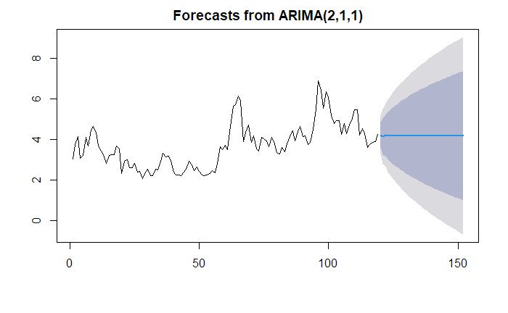

Cathay Pacific Airways

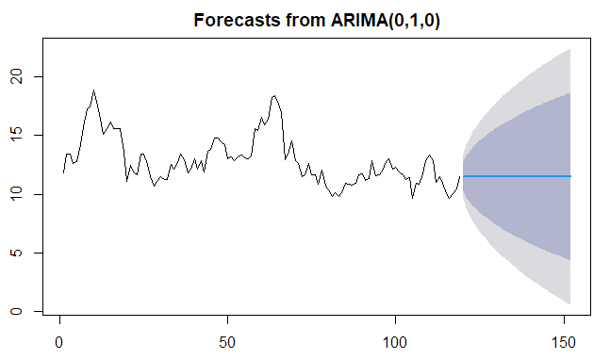
Air Canada

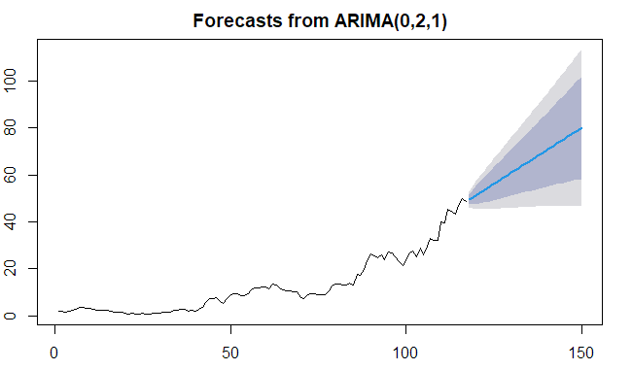
Lufthansa

0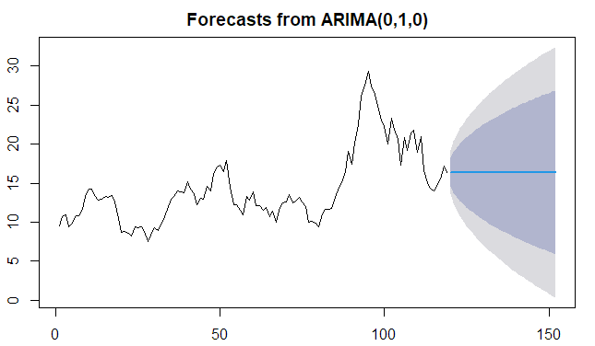
Air New Zealand

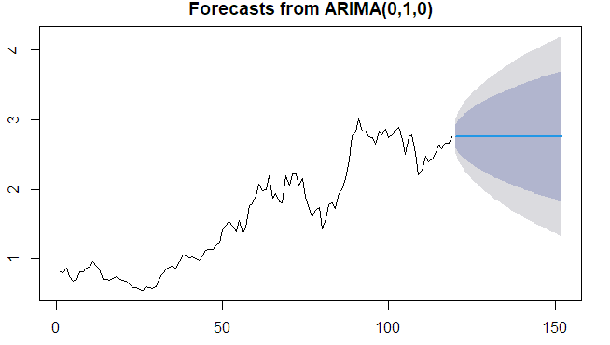
EVA Air

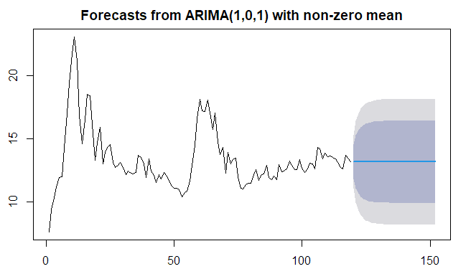
Southwest Airlines

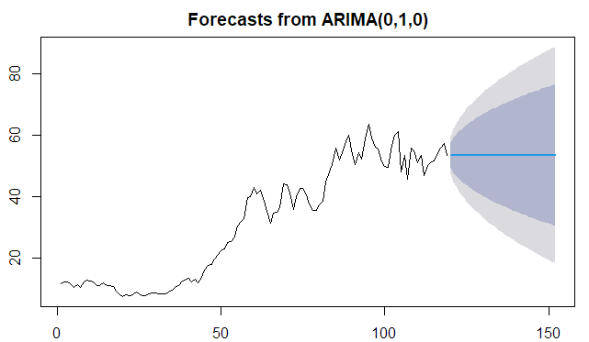

Ryanair

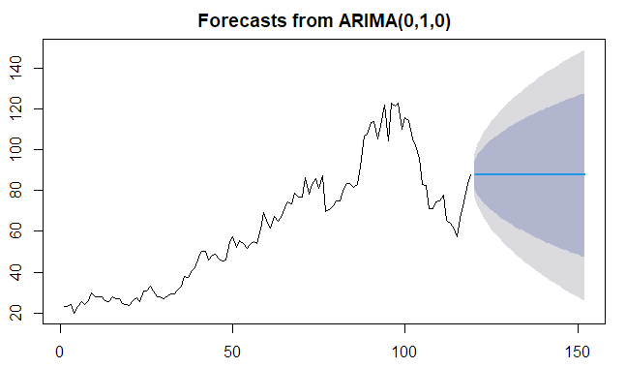
LATAM Airlines

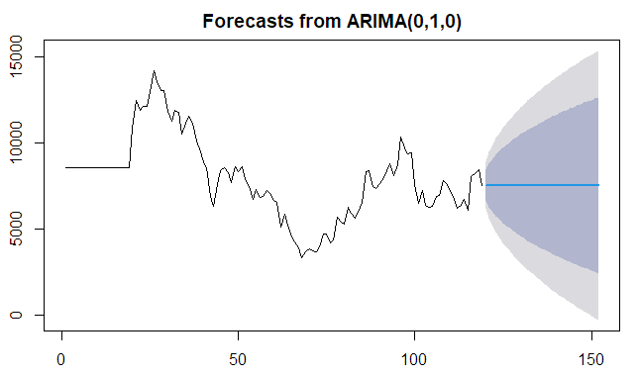
Jin Air

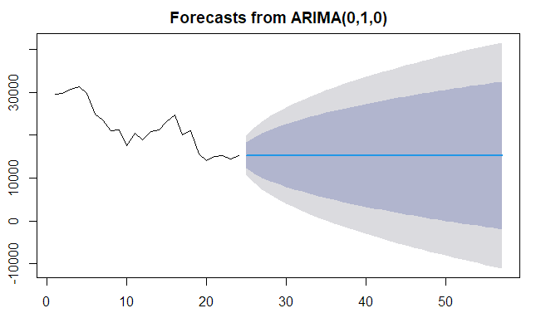

EL AL

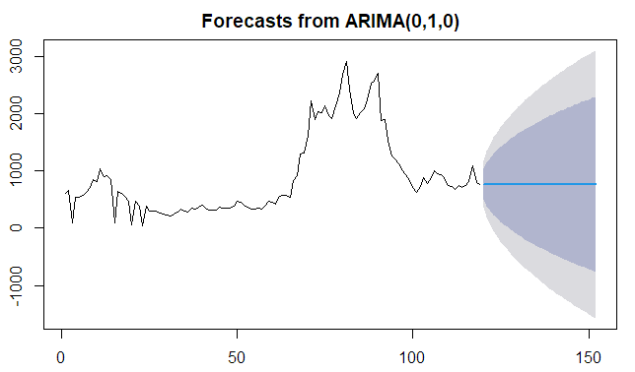
IndiGo

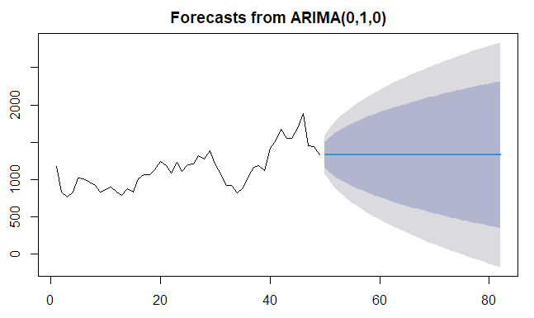
Alliance Aviation Services

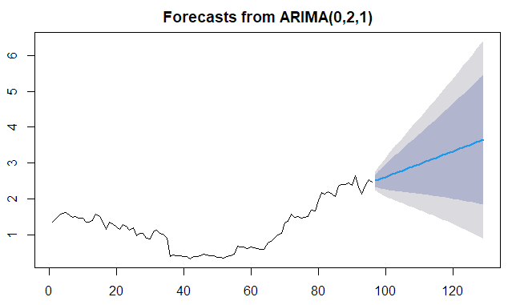
Gol Transportes Aéreos

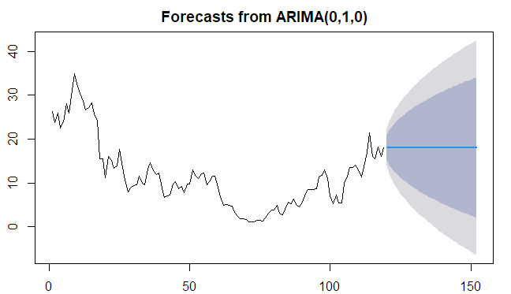
Hawaiian Airlines

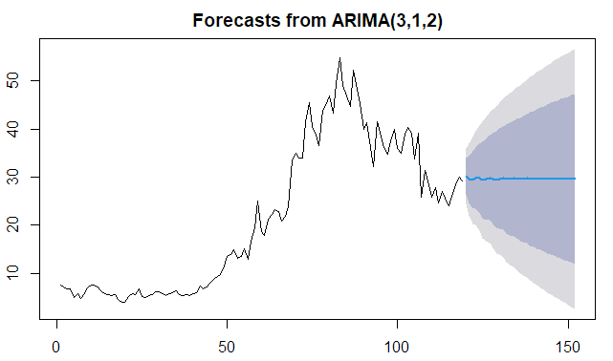
Azul Airlines

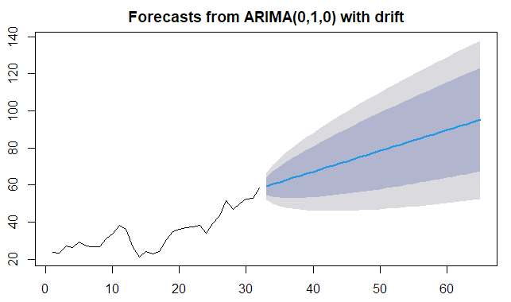
Pegasus Airlines

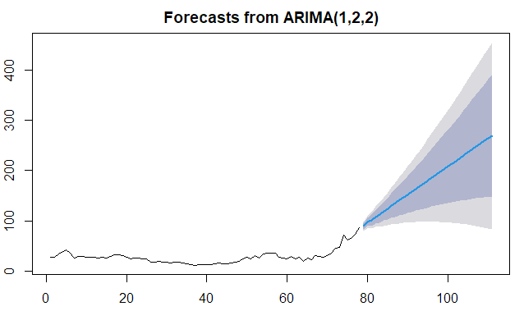
Controladora

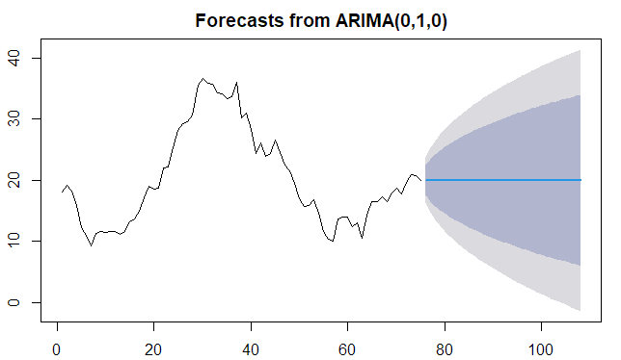
JetBlue Airways

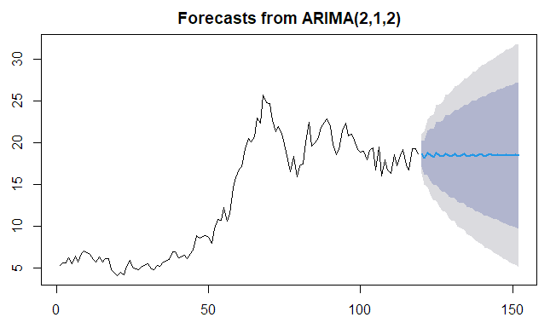
Enter Air

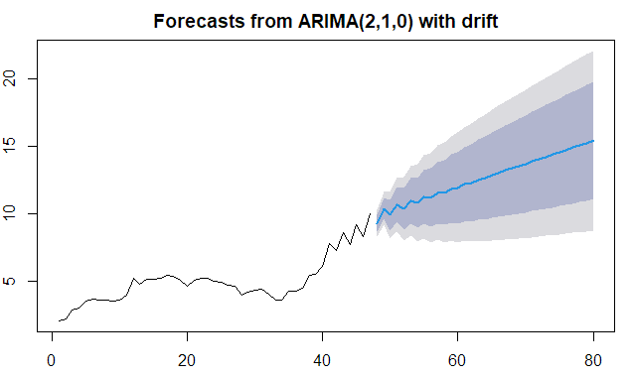
Cebu Air

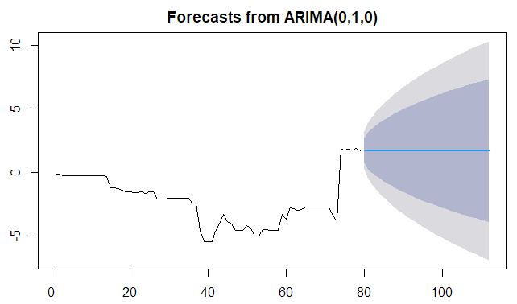
Spirit Airlines

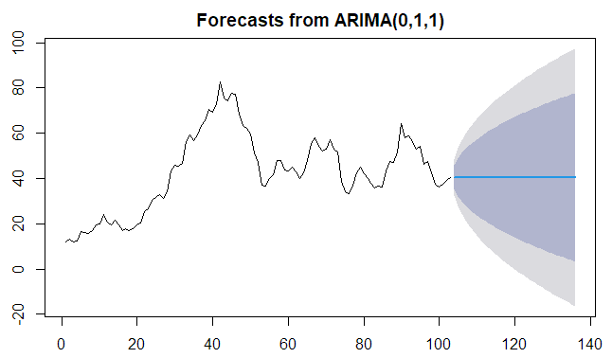
Icelandair

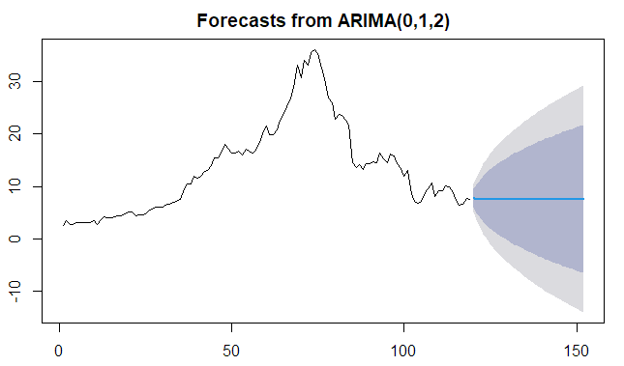
SkyWest Airlines

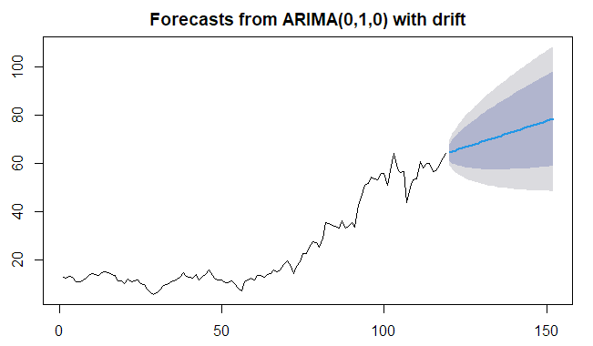

Appendix 2. Models of the airlines presented in Chapter 3.
Air France-KLM
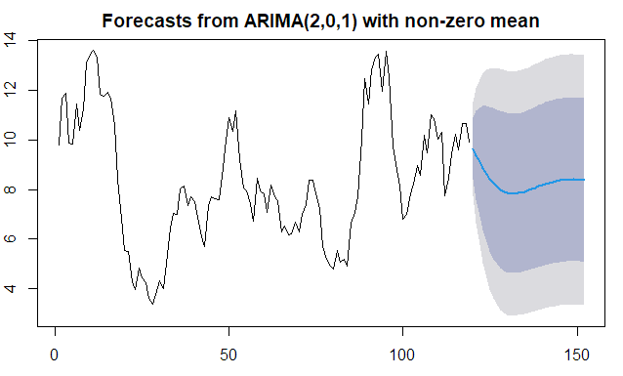
China Airlines
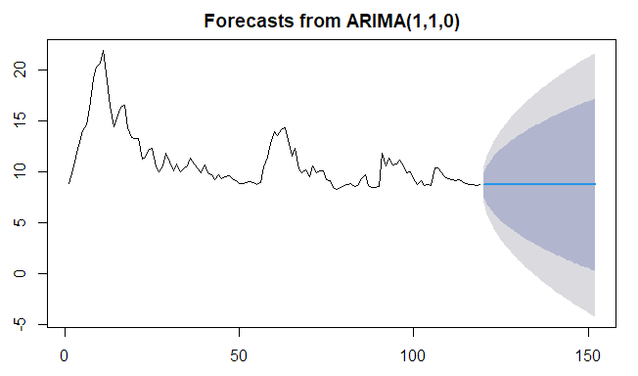

Delta Airlines
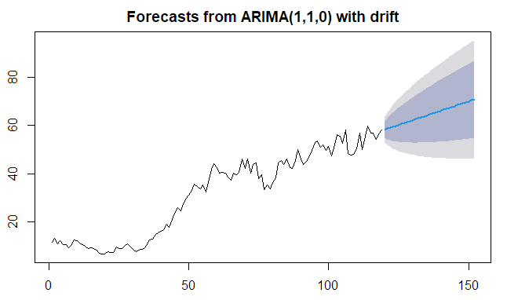
Korean Air
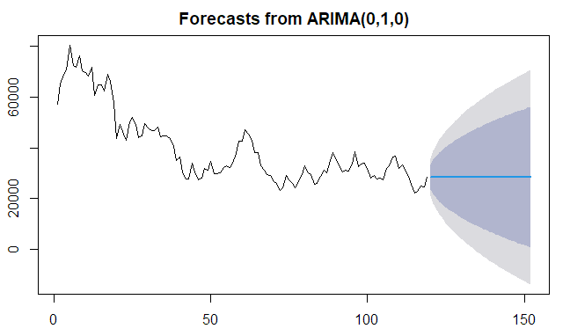
Qantas
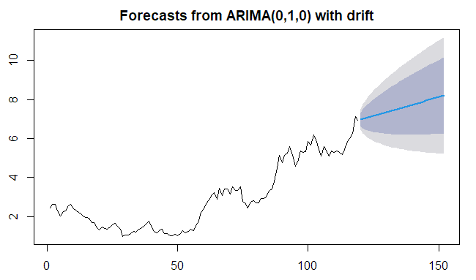
Finnair
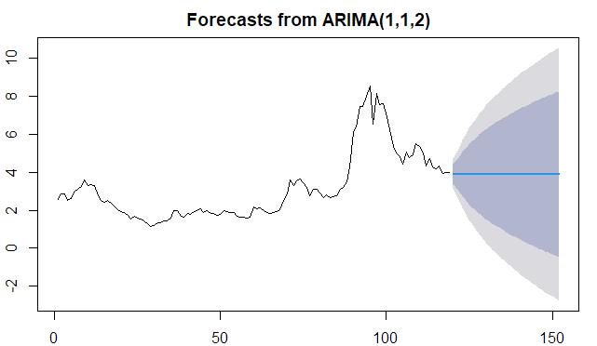
American Airlines
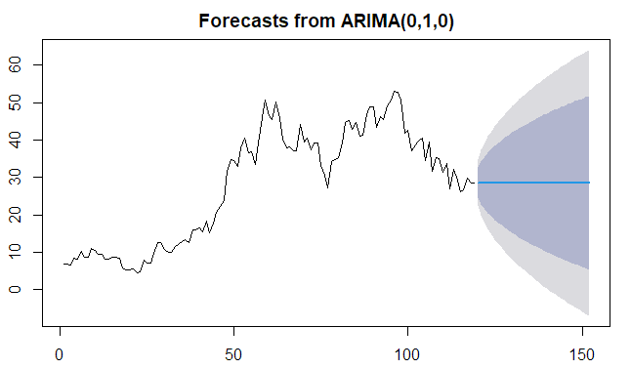
Japan Airlines
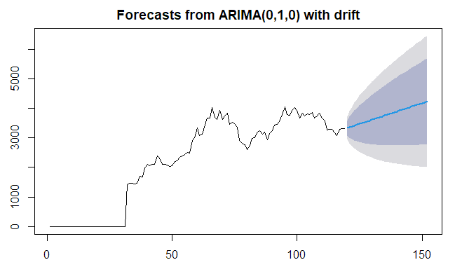
Turkish Airlines
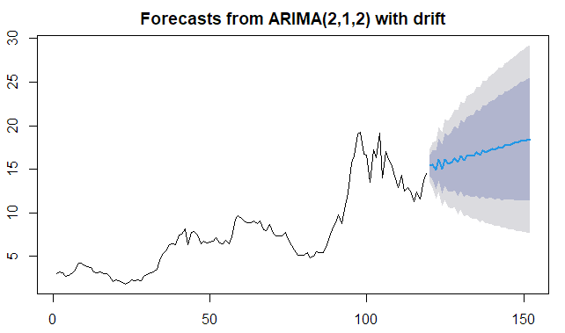
Aegean Airlines
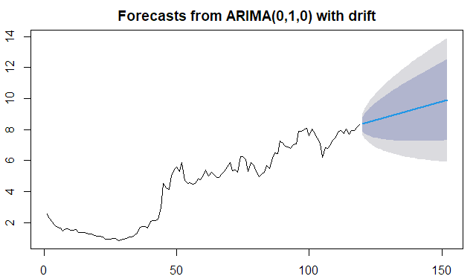
Singapore Airlines
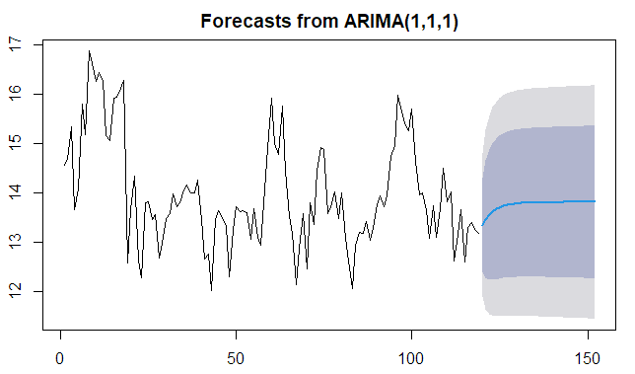
Copa Airlines
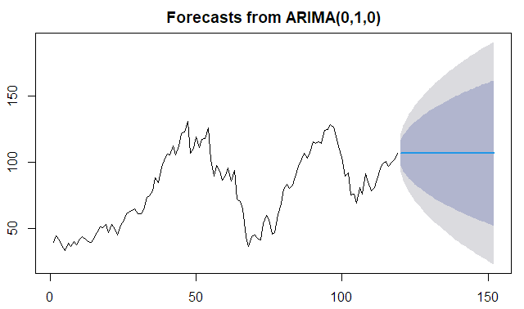
Wizz Air
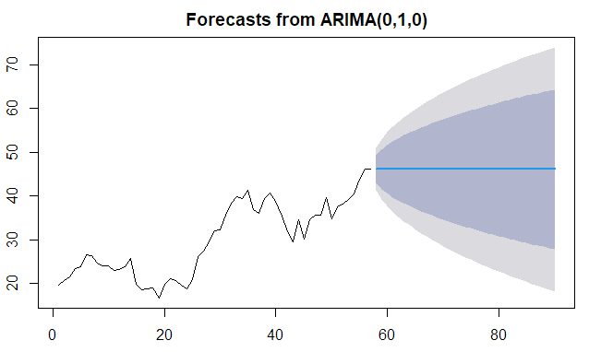
Allegiant Air
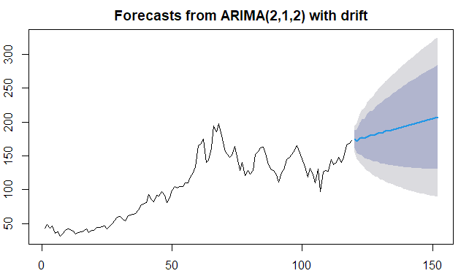
Alaska Airlines
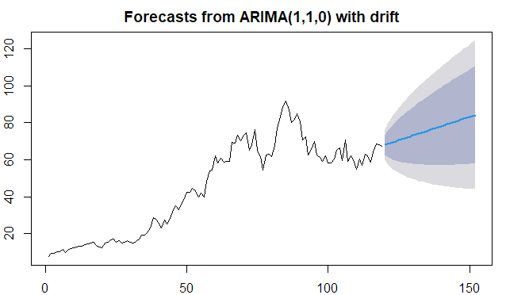
Air Arabia
