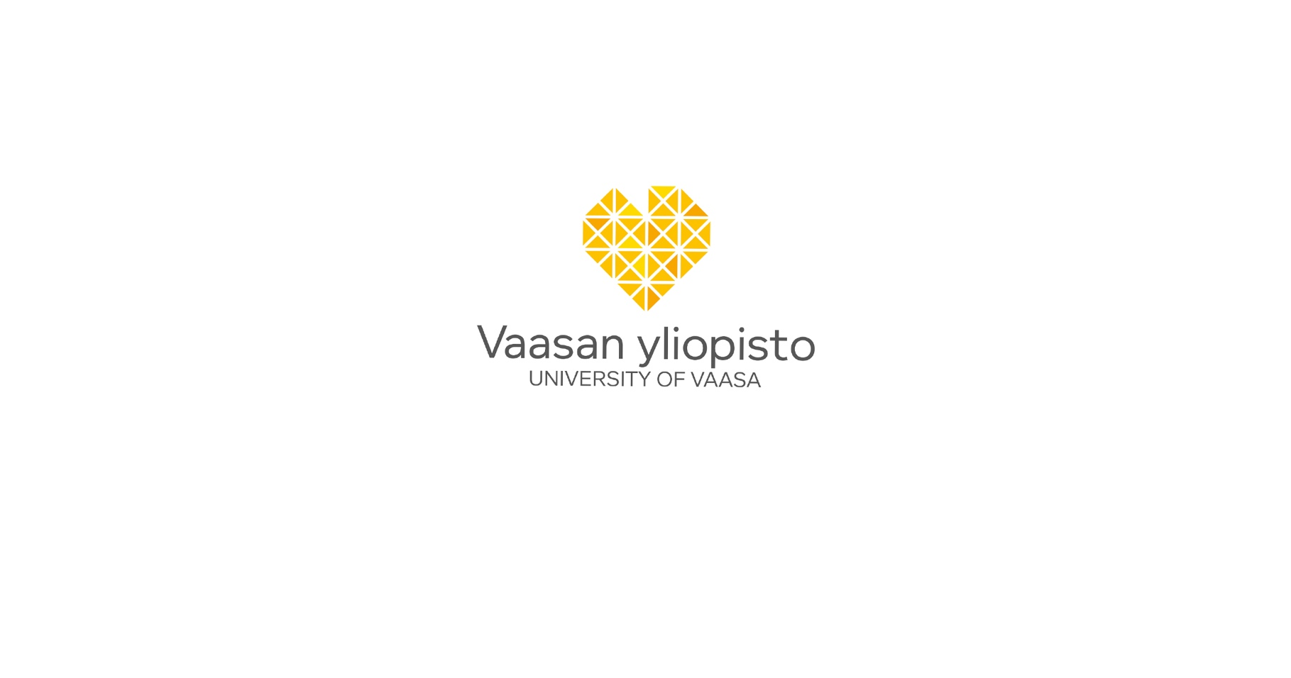
Laura Ylitalo
Creating the market image of reusable packaging
Case: 4everPack

Vaasa 2022

School of Marketing and Communication
Master’s thesis
Marketing Management

UNIVERSITY OF VAASA
School of Marketing and Communication
Author: Laura Ylitalo
Title of the Thesis: Creating the market image of reusable packaging : Case: 4everPack
Degree: Master of Science in Economics and Business Administration
Programme: Marketing Management
Supervisor: Hannu Makkonen
Year: 2022 Pages: 81
ABSTRACT:
The single-use philosophy of FMCG (Fast-Moving Consumer Goods) products generate increasing amounts of waste and environmental emissions. The 4everPack project aims to develop reusable packaging for FMCG products to reduce their environmental impact and change the single-use packaging market more sustainable and environmentally friendly.

The thesis is conducted as a part of the 4everPack research project by the University of Vaasa and the Technology Research Center VTT Oy. The purpose of the thesis is to address the early phase of market shaping through market image creation of the 4everPack project. The aim of the thesis is to create the market images of reusable packaging in the context of the 4everPack project. The first objective of the research is to describe the early phase of market shaping through the creation of market image and shared market image. The second objective is to form a framework for the market image creation process. The third objective is to create the market images of the 4everPack project.

The theoretical part of the thesis discusses the theory of reusable packaging and market shaping. The theory of the thesis focuses on the early phase of market shaping, where the market image of desired solution is formed, and the market image is expanded into a shared market image through ecosystem development and value co-creation. The research has been conducted as a qualitative study using extensive case study as a research method. The material of the study has been collected with semi-structured stakeholder interviews and workshops.

Based on the interview findings, five use cases for the 4everPack project have been created. The use cases serve as the market images for reusable packaging. The use cases have been developed further in research workshops by the co-operation of the project actors. As a result of the research, the goals for the use cases, ecosystem value chains and value propositions have been formed. In addition, general challenges have been found that must be resolved before the use cases can be developed into realized market images in the market innovation phase. The research brings further understanding of the early stage of market shaping, where the aim is to form an image of the desired solution and the pursued change in the market through co-operation of the ecosystem. On a practical level, the research creates use cases for reusable packaging for the 4everPack project, which can be refined into business models with further development.

KEYWORDS: Reusable Packaging, Market Shaping, Market Image, Ecosystems, Value Co-Creation

VAASAN YLIOPISTO
Markkinoinnin ja viestinnän yksikkö
Tekijä: Laura Ylitalo
Tutkielman nimi: Creating the market image of reusable packaging : Case: 4everPack
Tutkinto: Kauppatieteiden maisteri
Oppiaine: Markkinoinnin johtaminen
Työn ohjaaja: Hannu Makkonen
Valmistumisvuosi: 2022 Sivumäärä: 81
TIIVISTELMÄ:
FMCG (Fast-Moving Consumer Goods) -tuotteiden kertakäyttöpakkaukset tuottavat kasvavissa määrin jätettä ja ympäristöpäästöjä. 4everPack-projekti pyrkii kehittämään FMCG-tuotteille uudelleen käytettäviä pakkauksia vähentääkseen niiden ympäristövaikutuksia sekä muuttaakseen kertakäyttöön perustuvaa pakkausmarkkinaa kestävämmäksi ja ympäristöystävällisemmäksi.

Tutkimus on toteutettu osana Vaasan yliopiston ja Teknologian tutkimuskeskus VTT Oy:n 4everPack-tutkimusta. Tutkimuksen tarkoituksena on käsitellä markkinoiden muokkaamisen alkuvaihetta 4everPack-projektin markkinakuvien luomisen avulla. Tutkimuksen tavoitteena on muodostaa uudelleen käytettävien pakkausten markkinakuvia 4everPack-projektin kontekstissa. Tutkimuksen ensimmäisenä osatavoitteena on kuvailla markkinoiden muokkaamisen alkuvaihetta markkinakuvan ja jaetun markkinakuvan luomisen kautta. Toisena osatavoitteena on luoda viitekehys markkinakuvien luomisen prosessille. Kolmantena osatavoitteena on luoda 4everPack-projektin markkinakuvat.

Tutkimuksen teoriaosuudessa käsitellään uudelleen käytettävien pakkausten sekä markkinoiden muokkaamisen teoriaa. Tutkimuksen teoria painottuu markkinoiden muokkaamisen alkuvaiheeseen, jossa muodostetaan halutun ratkaisun markkinakuva, sekä laajennetaan markkinakuvaa ekosysteemin kehittämisen ja arvon yhteisluomisen avulla jaetuksi markkinakuvaksi. Tutkimuksessa on luotu markkinoiden muokkaamisen alkuvaiheen viitekehys. Tutkimus on toteutettu kvalitatiivisena tutkimuksena käyttäen laajaa tapaustutkimusta tutkimusmetodina. Tutkimuksen materiaali on koottu puolistrukturoitujen sidosryhmähaastatteluiden sekä -työpajojen avulla.

Tutkimuksessa on muodostettu haastatteluiden perusteella 4everPack-projektille viisi käyttötapausta, jotka toimivat uudelleen käytettävien pakkausten markkinakuvina. Käyttötapauksia on kehitetty tutkimuksen työpajoissa yhteistyössä projektin toimijoiden kanssa. Tutkimuksen tuloksena on saatu muodostettua käyttötapausten tavoitteet, ekosysteemien arvoketjut sekä arvoehdotukset. Lisäksi on löydetty yleiset ongelmakohdat, jotka tulee ratkaista ennen kuin käyttötapauksia voidaan kehittää toteutuneiksi markkinakuviksi markkinainnovaatiovaiheeseen. Tutkimus tuo lisäymmärrystä markkinoiden muokkaamisen alkuvaiheesta, jossa pyritään muodostamaan ekosysteemin yhteistyöllä kuva halutusta ratkaisusta ja markkinan lopputuloksesta. Käytännön tasolla tutkimus luo 4everPack-projektin osallistujille uudelleen käytettävien pakkausten käyttötapaukset, jotka voidaan jatkokehityksellä jalostaa liiketoimintamalleiksi.

AVAINSANAT: Reusable Packaging, Market Shaping, Market Image, Ecosystems, Value Co-Creation

Contents

1 Introduction 7
1.1 Research purpose and objectives 8
1.2 Research method and approach 8
1.3 Research structure 9
2 Literature review 10
2.1 Reusable packaging 10
2.1.1 Reusable packaging models 12
2.1.2 Fast-Moving Consumer Goods 14
2.2 Designing market image 14
2.2.1 Market shaping 14
2.2.2 Market image 18
2.3 Creating shared market image 20
2.3.1 Ecosystems 23
2.3.2 Value co-creation 25
2.3.3 Business model validation 27
2.4 Framework 28
3 Methodology 30
3.1 Research method 30
3.2 Data collection method 33
3.3 Case 4everPack 35
3.4 Data collection 37
3.5 Data analysis 39
3.6 Validity and reliability of the study 40
4 Findings 42
4.1 4everPack market images 42
4.1.1 Interview findings 42
4.1.2 Use cases 44
4.1.2.1 Food delivery system for hospitals 45
4.1.2.2 Reusable takeaway food packaging 46
4.1.2.3 Reusable grocery home delivery package 47
4.1.2.4 Reusable bottle packaging for detergents 47
4.1.2.5 Reusable takeaway pizza packaging 48
4.2 4everPack shared market images 49
4.2.1 Ecosystem workshop 49
4.2.2 Value co-creation workshop 50
4.2.3 Use case workshops 52
4.2.3.1 Food delivery system for hospitals workshops 52
4.2.3.2 Reusable takeaway food packaging workshops 55
4.2.3.3 Reusable grocery home delivery package workshops 57
4.2.3.4 Reusable bottle packaging for detergents workshops 59
4.2.3.5 Reusable takeaway pizza packaging workshops 62
5 Conclusions and discussion 65
5.1 Main findings 65
5.2 Suggestions for further research 66
5.3 Limitations of the research 67
References 69
Appendices 76
Appendix 1. 4everPack Interview Guide 76

Pictures

Picture 1. Reuse models. (Ellen MacArthur Foundation, 2019) 14
Picture 2. Collaborative market driving. (Maciel & Fischer, 2020) 22
Picture 3. Circular business ecosystem. (Bertassini et al. 2021) 25
Picture 4. 4everPack consortium. (4everPack Project Plan, 2021) 37
Picture 5. 4everPack use cases. 46
Picture 6. Food delivery system for hospitals value chain. 54
Picture 7. Reusable takeaway food packaging value chain. 57
Picture 8. Reusable grocery home delivery package value chain. 59
Picture 9. Reusable bottle packaging for detergents value chain. 62
Picture 10. Reusable takeaway pizza packaging value chain. 65

Figures

Figure 1. Theoretical framework of the thesis. 29
Figure 2. Methodological approach. (adapted from Bertassini et al. 2021) 36

Tables

Table 1. Interviews conducted in the research. 39
Table 2. Workshops conducted in the research. 40
Table 3. Interview findings. 45
Table 4. Use case A actors. 47
Table 5. Use case B actors. 48
Table 6. Use case C actors. 49
Table 7. Use case D actors. 50
Table 8. Use case E actors. 50
Table 9. Food delivery system for hospitals value proposition canvas summary. 56
Table 10. Reusable takeaway food packaging value proposition canvas summary. 58
Table 11. Reusable grocery home delivery packaging value proposition canvas summary. 61
Table 12. Reusable bottle packaging for detergents value proposition canvas summary. 64
Table 13. Reusable takeaway pizza packaging value proposition canvas summary. 66

Introduction
Natural resources and materials are taken and used by companies and consumers in an increasing manner, and the single-use philosophy is pushing the earths bearing capacity. Global economy strives to be restructured to become more sustainable and less resource intensive. The plastic waste mismanagement is resulting in serious pollution, and emissions will continue to rise if no action is taken to prevent it. If the development continues the same, by 2050 12 billion tonnes of plastic waste will be in landfills and in natural environment. (Geyer et al., 2017)

According to Ellen MacArthur Foundation (2019) reusable packaging is a key part of the solution to decrease plastic pollution and greenhouse gas emissions. Reusable packaging can also help to build brand loyalty, improve user experience, gather intelligence, optimize operations, adapt to individual needs, and cut costs.

This master’s thesis case 4everPack is a collaborative research project between the University of Vaasa and the Technology Research Center VTT Oy. 4everPack is a research about Fast-Moving Consumer Goods reusable packaging, and the aim of the project is to replace Fast-Moving Consumer Goods single-use packages with reusable packages (4everPack, 2021). Products that are purchased and consumed constantly to meet the consumers continuous demand are called Fast Moving Consumer Goods (FMCG) (Muranko et al., 2021). In current economy FMCGs are based on single-use and disposability, but in the 4everPack project single-use FMCG products are sought to be replaced by reusable products. The strategy behind reuse is to extend the value of the resources by slowing the material flows (Muranko et al., 2021).

According to Nenonen and Storbacka (2020b) market-shaping is often driven by a sense of dissatisfaction with the current solution, so the individual or the collective starts to seek for alternative options. Market shaping requires a scalable vision, a market image, for the future market.
According to Iansiti and Levien (2004), future competition is not focused on individual companies and their innovations, but rather on business ecosystems. Ecosystems are adaptive and complex systems that are based on various related components (Von Bertalanffy, 1972). According to Adner (2006), business ecosystems are collaborative arrangements in which companies combine their offerings and resources into a unified solution, and thus create value they would not have been able to create without the ecosystem. When taking actions toward more sustainable business, the companies should understand their impact on the ecosystem in which they operate, as it is the reality in todays networked environment (Iansiti & Levien, 2004).

Research purpose and objectives
The purpose of this thesis is to address the early market shaping process through market image creation of the 4everPack research project. The aim is to create the market images of the reusable packaging in the 4everPack context.

The research question is ‘what is the process of market image creation’. To get a comprehensive answer to the research question the following research objectives are set:

- The first objective is to describe the early phase of market shaping through market image and shared market image creation
- The second objective is to form a framework for the market image creation process
- The third objective is to create the 4everPack (shared) market images.

Research method and approach
The research of this thesis is done by qualitative methods; the research is conducted as an extensive case research, and the research material is collected through stakeholder interviews and research project workshops. The interviews are semi-structured, themed interviews, and the workshops focus on the co-creation of the ecosystems and values of the 4everPack project use cases.

Research structure
The thesis is divided into five main chapters. The first main chapter contains the introduction, the purpose, the research method, and the structure of the thesis. The second main chapter is the theory chapter, in which the research framework is formed. The theory chapter discusses reusable packaging, market shaping, market image and shared market image creation. The third main chapter presents the methodological choices of the research, the research case, and data collection and analysis. The fourth main chapter presents the results of the research, and the fifth main chapter reviews the conclusions and suggestions for further research.

Literature review
In this chapter a theoretical review of reusable packaging, reusable packaging models and Fast-Moving Consumer Goods (FMCG) packaging will be formed. After the reusable packaging, market image creation will be covered through the theory of market shaping, market image, shared market image, ecosystems, and value co-creation. Lastly a theoretical framework for the market image creation will be formed.

Reusable packaging
Most of the virgin materials today are used for packaging, and for example in Europe 50% of paper and 40% of plastics are used for packaging materials (Geyer et al. 2017). Up to 50% of marine litter consist of single use plastic items, and European Union (2019) has set a directive to restrain disposable single use plastic usage, including the plastic used in the packaging. The directive aims to lessen plastic waste, promote circular economy, and harmonize product regulation in the EU market. Single use packaging is only used once, and after the usage it is recycled or disposed (Golding, 1999). Reusing consists of for example returning end-of-life products for refurbishment or second-hand markets (Aarikka-Stenroos et al., 2021). In the context of the 4everPack project, reusing refers to using the same packaging to the same purpose as long as it is in sufficient condition to fulfil the purpose. According to Ellen MacArthur Foundation (2017) reusable packaging options could replace at least 20% of the plastic packaging.

Today packaging is seen as something as light and inexpensive as possible, and the way we see packages could be changed by innovating reusable packaging. Through the innovating of reusable packages, the packages could be seen as assets with high value that can deliver notable benefits. Reusable packaging holds the opportunity of 10 billion USD for innovations that can bring business profits and user benefits, and with reusable packaging plastic pollution can be lessened. (Ellen MacArthur Foundation, 2019).

In the last decades the single-use packages have increased rapidly, and the environmental issues they present need a solution. Reusable packaging allows more value to be retained compared to packaging recycling, and most environmental impact measures show that reusable packaging outperforms single-use packaging. The results are dependent on customer behaviour and the impact of the transportations and reuse chains, so the reusable packaging logistics should be designed to minimize negative rebounds. With reusing, environmental impacts and material usage are decreased when the material and product functionality are retained, and through that environmental and potential economic benefits are greater than with single-use packaging. (Coelho et al., 2020; Greenwood et al., 2021).

Reusable packaging can significantly help to reduce waste and environmental impacts of the packaging compared to single use packaging. According to the research by Greenwood et al. (2021), both refill and return systems with plastic containers for takeaway food have a lower carbon footprint than single use plastic containers in just 2 to 4 uses. According to the research conducted by Goellner and Sparrow (2014) reusable transportation containers emit less carbon dioxide and generate less acidification, eutrophication, photochemical ozone, human toxicity, and post-consumer waste compared to the single-use containers.

Reusable packaging brings also other diverse benefits. When refills for reusable packaging are given in compact form, such as concentrates or solids, the packing and transportation expenses for reusable packaging can be reduced. The reusable packaging can be adapted to individual needs, as it can allow consumers to mix and match flavours, personalize the packaging, or choose the desired quantities. With reusable packaging the operations can also be optimized by sharing the reusable packaging across networks, sectors, and brands. Through this a preferable scale for distribution and logistics can be achieved. Reusable packaging can also help to build brand loyalty through deposit and reward schemes. In addition, better user experience can be achieved by improving the functionality, look and feel of the reusable packaging. The packaging can be more high-end if the production costs are divided by many uses. By combining digital technology such as RFID tags, sensors, and GPS tracking into the packaging system, intelligence information can also be gathered. (Ellen MacArthur Foundation, 2019)

Reusable packaging models
The aspects of the package influence highly what consumers are willing to reuse, and important factors are the material, type, and closure mechanisms of the packaging. The most favourable packaging material for reusable packaging is glass, and consumers are most willing to reuse jars, bottles, and boxes. Consumers are more reluctant to reuse wraps, cans, and aerosols. The nature of the product, state of matter of the contents and where the product is consumed do not have an impact on what people are willing to reuse. From that it can be deducted that the packaging type and material are the most significant factors on the reuse engagement, and people are more willing to engage in systems that they are already familiar with. An interdisciplinary approach which considers both environmental impacts and willingness to engage is the best approach to reusable packaging. (Greenwood et al., 2021)

Packages can be classified based on the functionality layer into three categories; primary packaging, that is first in direct contact with the product and holds it, secondary packaging, that is the outer layer of the primary packaging, and tertiary packaging that is used for bulk handling, storage, and shipping (Pålsson, 2018). BC2 reuse models can differ in the terms of the packaging ownership and whether the user leaves home to refill or return the packaging. According to Ellen MacArthur Foundation (2019) there are following reusable packaging models: refill at home, where the consumer refills the reusable container at home, return from home, where the packaging is picked from home by logistics service, refill on the go, where the consumer refills the reusable container away from home, and return on the go, where the consumer returns the packaging to a drop-off point. According to Muranko et al. (2021) and Bocken at al. (2022), the Fast-Moving Consumer Goods sector reuse models are the following: consumer replenishes or reconditions, consumer replenishes at home by service, consumer replenishes on the move by service, consumer brings and company replenishes by service, and company replenishes for consumer by service. In the first three reuse models the consumer maintains the packaging and is involved at the replenishing or reconditioning, and in the last two the consumer brings back or disposes the reusable packaging. In this framework the role of the consumer and the provider are specified, which aims at determining who performs the fundamental activities at the system.

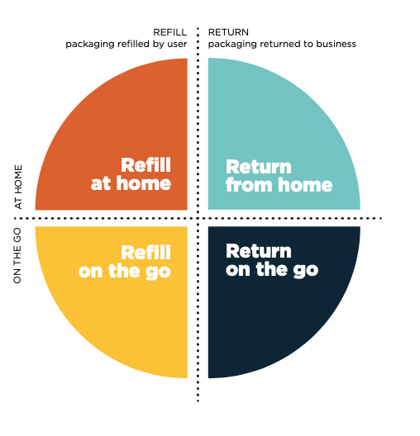
Picture 1. Reuse models. (Ellen MacArthur Foundation, 2019)

Logistics and transportation, market volume, level of standardization, reusable container return rates, hygiene, and personnel engaged in the process are all aspects that impact the feasibility of reusable packaging systems. Furthermore, establishing a reusable packaging system has various advantages for retailers and brands, including increased consumer loyalty, a more sustainable image, and greater variety and personalization. Customers benefit from reusable packaging models because they decrease waste, may take advantage of pricing incentives such as discounts for reuse, and enhance product diversity. (Coelho et al., 2020). Before adopting reusable packaging models, the companies need to consider whether the reusable packaging in hand is environmentally and economically feasible, how to design the logistics and what are the operations management implications for reusable packaging (Mahmoudi & Parviziomran, 2020).

Fast-Moving Consumer Goods
Fast-Moving Consumer Goods (FMCGs) are consumer goods that are regularly purchased and consumed. They are food and non-food items such as personal care and cosmetics, detergents, and cleaning supplies. The FMCGs industry is known for its great sales volume and affordable prices. According to circular economy concepts, FMCGs should be created in a way that fosters the maximum resource utility. To begin, items should be made from renewable and sustainable materials with the goal of returning to the product lifecycle as reusable packaging before being recycled. Increased use of renewable energy, improved operations, and waste recovery are the most prevalent circular economy initiatives among FMCG companies. Within the circular economy agenda, the FMCG business offers opportunities for innovation, however, owing to the sector's unpredictability and complexity, this is frequently difficult in practice, and there are currently few radical and innovative ideas. (Muranko et al., 2021; Bocken et al., 2022).

Designing market image

Market shaping
A shift in business logic from a linear, goods-dominated model to a networked, collaborative, service-dominated model has changed the logic of value generation. The boundaries between companies, industries, and markets are becoming increasingly porous, fuzzy, and transient. As the focus shifts to co-creation opportunities with both customers and suppliers, the understanding and defining of markets becomes increasingly interesting. (Vargo & Lusch, 2004; Storbacka & Nenonen, 2011)

Markets must be regarded as a setting for value co-creation, not just for production and consumption. In recent years, as the marketing literature has increasingly construed markets as malleable entities, research studies on market-shaping methods have gotten a lot of attention. These are proactive, purposeful actions taken by a company with the goal of reshaping its operational environment, which includes direct customers, customers' customers, and other stakeholders such as competitors. Markets are configurations of interdependent market features that help the formation and institutionalization of resource connections, allowing market actors to have a higher density of resources. (Kindström et al., 2017; Nenonen et al., 2019; Nenonen & Storbacka, 2020)

According to Storbacka and Nenonen (2011), market principles include both exchange and use value, as well as acknowledging that markets are socially constructed. Markets should be viewed as (business) ecosystems, with the network of relationships between the complementary and competing entities at the center of this systemic approach. Markets are places where market participants combine resources to co-create value and interact to increase their resource density. Based on this view, markets are not given or predetermined structures in which actors compete for positions. To exploit current and new possibilities, market actors will define subjective market definitions by finding the suitable networks to join.

According to Storbacka and Nenonen (2011), when markets are viewed as a configuration of market actors engaged in market activities, the market configurations are always changing as new actors and participants join the scene and contribute new ideas and business model features to the network. Through this action, the configuration’s marketness evolves and results in more potential value and opportunities for co-creation. Working on the mental and business models can help an actor affect the market configuration. The actor's mental and business models are strengthened by the actor's network position, clout, and the fact that changes in any aspect evoke reactions from other actors. Actors must create new market capabilities such as value sensing, market measurement, pricing logics, and market scripting, among others. According to Baker et al. (2019), numerous entities within a service ecosystem, such as innovation networks, research institutes, and universities, can drive innovation. Second, because markets do not exist in a static state, they are always evolving as a result of the actions taken by people who operate inside them. Finally, all innovation is essentially a reorganization of value co-creation processes. In summary, this perspective recognizes that microlevel behaviours together define a market, and that when practices change, the market changes as well.

According to Kjellberg and Helgesson (2007) construction and concrete activities form and shape the markets. Storbacka and Nenonen (2011) define the interactions between market actors as market practices. According to Kjellberg and Helgesson (2007) and Storbacka and Nenonen (2011), there are three types of market practices: exchange, representational and normalizing practices. The exchange practices are activities that lead to the communication, refinement, and agreement of value propositions, as well as the re-configuration of network resources to actualize the value proposition and prospective financial transaction. The normalizing practices define or reinterpret the standards and conventions that will be implemented in a specific market. Market actors attempt to stabilize their business models by normalizing methods, as relative business model stability is a precondition for efficient operations, allowing for lengthy production runs and the learning curve effect. The representational practices are methods in which market participants' business models and market configurations are represented through shareable images. Firm presentations and market studies are examples of shared visuals. As a result, representational practices provide a way for market actors to make their business models visible to others, even if they don't have any direct contacts with them. Overall, the markets are formed through the continuous processes that link the exchange, representational and normalizing practices into interdependent chains that interfere with one another.

Market shaping extends past incremental changes that occur as a result of competition. In market-shaping, a focal firm takes purposeful actions in order to alter market characteristics by re-designing the exchange content, reorganizing the stakeholder network involved, and re-establishing institutions governing the behaviour of all stakeholders. The goal of these actions is to create new opportunities for stakeholders to link resources in the market in a way that increase value creation. Market shaping companies therefore identify the value potential of connecting intra- and interstakeholder resources in novel ways, change various market characteristics so that new resource linkages can be formed, and mobilize relevant stakeholders so that existing resources can be used in new ways. (Nenonen, Storbacka & Windahl, 2019)

According to Nenonen et al. (2019), a market shaping process consists of two distinct kinds of deeply embedded repeatable processes: triggering and facilitating. By directly influencing various aspects of the market, trigger capabilities create new stakeholder resource links. They re-design exchange, reconfigure networks, and re-form institutions. A company's facilitating capabilities determine how its triggering capabilities are utilized, since they relate to its creativity. By facilitating discovery of the value potential of new resource links, they enable market shaping, while simultaneously mobilizing relevant resources to enhance the impact of triggering capabilities. According to Kumar et al. (2000), companies are market shaping and driving through the following actions: the inspiration for a radical business concept usually comes from a visionary rather than traditional market research, and by implementing radical business innovations, market driving companies trigger industry breakpoints, which change the foundations of the industry. In addition to this, it is often necessary to teach potential customers how to consume the value proposition.

Examples of market shaping include the dramatic increase of digital platforms, enabling new stakeholders to interact and exchange ideas, crowdsourcing in several forms, the move toward XaaS (anything-as-a-service) in a variety of contexts, the energy generation reconfiguration and distribution of ecosystems to improve sustainability. (Nenonen, Storbacka & Windahl, 2019)

Market image
The term 'market image' refers to a visual representation of markets that can enable increased resource integration and value co-creation. Market shapers need to engage in market scripting to align the mental and business models of other market actors so that they reinforce the models of the scripting actor's market image. (Storbacka & Nenonen, 2011)

A market vision or image lies at the heart of any given current market configuration, to which the various market actors are aligned. In essence, a market image is a vision of a future market that is compelling and beneficial to the market shaper. Accordingly, a company seeking to shape a market will engage in deliberate market-shaping activities in order to reorganize the current market configuration in accordance with its vision. (Storbacka & Nenonen, 2011; Jaworski, Kohli & Sarin, 2020; Nenonen, Storbacka & Windahl, 2019; Flaig, Kindström & Ottosson, 2021)

Against the existing markets, the primary objective of companies is to develop the best market image they can, to ensure adequate decisions are made, notably which markets to enter and how to improve market orientation in existing markets. Accordingly, creating market images involves tapping into an already existing demand, or one that will exist in the future. (Kjellberg, Azimont & Reid, 2015)

Nenonen et al. (2019) view market image creation as a specific case of market-shaping, as it is likely that the same capabilities can be applied. With high degrees of uncertainty and complexity, market image creation is a longitudinal, non-linear process that necessitates different managerial capabilities and processes than incremental business development.

According to Kjellberg et al. (2015), as a starting point for discussing what market image might entail, the first dimension of market image creation is market structure. Our understanding of market structure is enriched by an extensive body of literature that goes beyond the micro-economic structure of buyer and seller concentration, entry barriers, and product differentiation. In particular, the network approach is concerned with connected market structures, rather than aggregated ones. A 'structural' market image can therefore be used to express classic issues such as new actors entering the market, actors leaving the market, changes in the division of labor between actors, and changes in the interconnectivity among actors.

In addition to this, recent studies have highlighted how individual actors are enacting exchanges, and what are the direct links between these variations and specific market images. The concept that markets are socio-material networks implies that market images also include the introduction of various market devices, such as algorithms, business models, retail interiors, and performance measures. New technologies, such as information or distribution technologies, often underpin these changes. Technical infrastructures developed for other purposes can offer many opportunities for market image creators and shapers. (Kjellberg, Azimont & Reid, 2015)

In market image creation it is also noticeable, that change agents are not limited to regulators or selling companies, but also include users and customers. Accordingly, markets can be influenced by influencing what market participants consider important when assessing a product or service, including their ability to monitor properties and consequences. (Kjellberg, Azimont & Reid, 2015)

To summarize, according to Kjellberg et al. (2015), markets are ongoing processes rather than stable entities, and market image creation is more than just the opening of new markets. Creating a market image involves successfully changing the current market structure, introducing new market devices, altering market behaviour, and reconstituting market agents. In general, market image creation is about changing how businesses are conducted. Market images can take a variety of forms, including new business models, new exchange technologies, and new evaluation techniques.

In order to create new market images, it is necessary to create a bounded network of buyers, sellers and goods, and arrange this network in a way that it channels interactions between them. The best ways to achieve that goal, are institutionalizing norms and regulations, establishing devices and technical infrastructures, generating and spreading images, models, and representations, and enacting practices, routines, and habits. (Kjellberg, Azimont & Reid, 2015)

Creating shared market image
According to Diaz Ruiz et al. (2020), as an empirical phenomenon, market shaping refers to one or more actors attempting to change the market landscape proactively instead of reacting to it. According to Flaig et al. (2021), Nenonen and Storbacka (2020) and Kjellberg and Helgesson (2007), as market shaping is a collective process, there are more implicit phases before the explicit phase of the market shaping, during which different market actors' images may still be less articulated and developing, and directions and coordination regarding their cohesion into a coherent mutual vision are absent or conflicting between them. In the early stages of the market shaping process, this can prevent the establishment of a valid and viable market image. However, according to Brege and Kindström (2020) and Baker and Nenonen (2020), collaboration can significantly improve a company’s’ performance, and ultimately it can shape a complex market system beyond what the collaboration partners could have imagined.

As a premise to collaborative market driving and market shaping, companies perceive market opportunities that they try to exploit individually, only to discover systemic obstacles such as limited economic and political power that prevent them from action. However, this realization does not automatically lead to collective actions, as collective identity is needed before collaboration can occur. Coordinators can help to bring together the individual actors by formulating a shared goal for the network that the actors see as worthy of collaborative pursuing. This method also brings in supply chain allies who can help these companies achieve their common goal by providing essential resources. The market actors employ their collective resources into economic and political initiatives to influence the development of a market that benefits the network as a whole once the actors have formed a coalition. Picture 3 summarizes the collaborative market driving stages. (Maciel & Fischer, 2020)

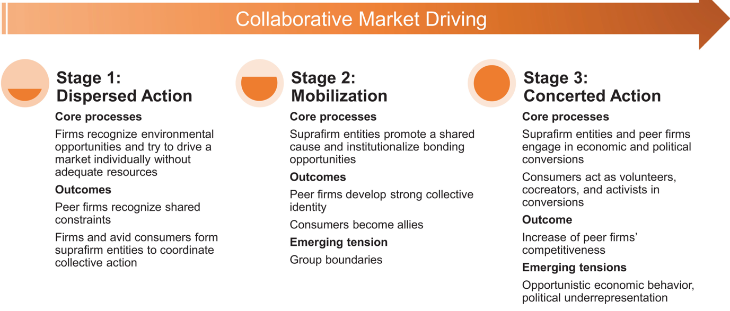
Picture 2. Collaborative market driving. (Maciel & Fischer, 2020)

Self-interest is not excluded from collaborative market driving. Companies can pursue to change markets to a degree that they would not be able to achieve otherwise than by co-operating. In addition, they can also collaborate because they profit from increasing the visibility of their offering, which is an important aspect in increasing the economic and cultural relevance of their market positions. As a result, collaborative market driving is a communal approach that involves self-interest but is not dominated by it. (Maciel & Fischer, 2020)

Creation of new markets is driven by evolving policies within an industry, as well as a growing ecosystem of complementary actors as macrolevel drivers. Activities at the market creating level can take place when new crossings between market participants occur, and new platforms for resource integration emerge. Thus, new interorganizational ties and networks arise, standardizing new behaviours and establishing the peer group of market participants. (Baker, Storbacka & Brodie, 2019)

According to Baker and Nenonen (2020), collective market work begins when persons with a common problem imagine alternatives, define their ultimate objective, and solicit the aid of peers to solve the problem. Legitimizing a collective entail negotiating and putting up rules and intermediate objectives. Furthermore, legitimate collectives utilize their market weight to advocate preferred arrangements and challenge incumbents. As a collective grows in strength, it will be able to target a larger number of market participants at higher levels of the market. In conclusion, adopting the emergence paradigm allows for simultaneous activities from the system level to the micro level. Different 'frames' inside the market system emerge as each intermediate stage progresses. (Baker & Nenonen, 2020)

According to Storbacka and Nenonen (2011), ‘focal actors’ are market participants who aim to affect a market configuration. Actors that want to influence market practices in a given market configuration can do so by improving their mental models and business models. Mental models determine how focal players understand the relevant market, and they are converted into diverse value creating techniques in business models. The interactions between the business elements of particular market players produce market practices. Market configurations are always changing and evolving as new actors enter the scene and different market actors contribute new ideas and business model aspects to the network. How much the actor may affect the market configuration is dependent on the focal actor’s position in the network and its power, and the way the other actors may react to any change because they are seeking to reshape the market in their favour.

For collaborative market shaping and market image creation it is essential that the other market actors' mental models and business models are aligned to support the shaping of the focal actor's mental and business models. Actors should express their views on how to configurate the market, create market images, as well as engage in collective activities which aim at creating a shared market image. (Storbacka & Nenonen, 2011)

Ecosystems
A market actor requires the help of others to develop a shared market image. To do this, the actor must comprehend the networks participants, their functions, any possible value propositions, and the resources and actions required to proceed. By significantly increasing customer value, market shaping companies can obtain a more sustainable competitive advantage. This new value proposition acts as the foundation for a new ecosystem. By building a fresh, distinctive company ecosystem, a large portion of the value proposition for market shaping is realized. As a result, after the value proposal has been articulated, attention must turn to understanding the connections between a group of actors and their activities in order to realize the value proposition. (Jaworski, Kohli & Sarin, 2020)

According to Möller et al. (2020), ecosystems are collections of collaborators for focal actors. According to Vargo et al. (2017), the term ‘ecosystem’ has been used in a variety of situations, including innovation management and strategy. The circular economy demands a systemic approach rather than focusing on individual companies and taking an ecosystem-based strategy can help with that. Ecosystem leaders create value by organizing ecosystems in collaboration with a community of stakeholders. Because a business ecosystem is a loosely connected corporate community, taking an ecosystem perspective can assist on explaining how the circular economy is implemented on a system level.

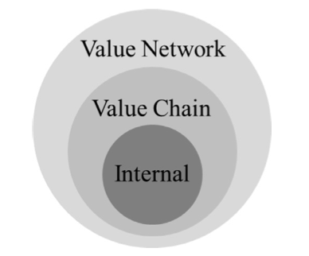
Picture 3. Circular business ecosystem. (Bertassini et al. 2021)

Ecosystems are considered as networks with a system-level outcome, implying that the ecosystem produces a better result than any single member could provide on their own. Second, ecosystems are made up of a varied set of players who are hierarchically autonomous yet perform a variety of roles within them. Third, interdependencies such as geographic closeness, technological complementarities, economic connections, and shared cognitive perspectives bond the varied actors within such ecosystems. Fourth, ecosystems have their own set of coordination mechanisms, which rely on role definitions and technical, economic, and cognitive alignment structures to create a balance of change and stability in ecosystem results. (Aarikka-Stenroos, 2021)

System thinking of markets entails a shift in viewpoint from parts to wholes, objects to connections, structures to processes, and measurement to mapping. (Vargo et al. 2017)

Many challenges arise when the business model is changed at the ecosystem level, such as how to incentivize ecosystem partners, how to share risk and revenue, and how to adapt roles and responsibilities among partners. The change to circular business models affects not just a single company's business strategy, but also the whole ecosystem, and successful circular economy operations involve orchestration of ecosystem partners. (Parida et al., 2019)

An ecosystem's view on market shaping can be seen of as a multi-actor process in which a network of stakeholders interacts by negotiating the design of new products. Actors experiment with various value propositions and negotiate with key actors to get them involved with the market offering or 'market image' that is intended to result in market (re)formation. The mixing of resources in a service ecosystem is almost never fully finished or closed, but rather expands, as growing number of actors get involved in the market-shaping process. (Frow et al., 2014; Vargo and Lusch, 2011).

To summarize, the ability to comprehend a larger system of actors, comprehend how new resource linkages can be created within this system, recognize the institutional arrangements that govern all actors, and mobilize actors for exchange-based and non-exchange-based resource contributions are all necessary for focal market shaping actors to be able to identify opportunities for market shaping. Actor engagement is therefore crucial to market shaping. (Storbacka 2019)

Value co-creation
As we transition toward a circular economy, value is a core concept. Values are a set of benefits that are delivered to stakeholders as the result of an exchange. During the implementation of a circular business model, companies need to understand the gains and benefits that all stakeholders in the business ecosystem can derive from it. Despite being inherent to business models, circular captured values can change from one stakeholder to another. Stakeholders are thus essential to understanding the distribution flow of circular captured values. (Bertassini et al. 2021)

Value propositions play a key role in market shaping. Complex systems thinking, which sees markets as ecosystems, indicates that there is no way to predict or control a market system's development as there is no center or central control mechanism in market systems. Instead, they evolve from a mix of deliberate influence and random emergence, in which there is no simple law of cause and effect. As a result, market change occurs as a continuous balance between deliberate design efforts (i.e., market shaping) and spontaneous evolution. Market shaping seeks to enhance the value creation and realization of actors within a market system. It is the ability to create, access, deploy, combine, and exchange resources that create new value, indicating that the key lies in the ability to do so. The purpose of a market shaping value proposition is to explain how a focal firm can enhance its resource integration by mobilizing actors. A market shaping value proposition conveys what kind of enhanced resource integration market actors will receive after the market is shaped. Market shaping value propositions can be considered as a strategic instrument that provide new resource integration opportunities by orchestrating resource links across different actors within a market system and organizing actors to engage in new resource integration activities. (Nenonen, Storbacka, & Windahl, 2019; Nenonen et al. 2020)

According to Nenonen et al. (2020) a value proposition that shapes the market will likely cover more than one value dimension. Taking into account the broader focus of market shaping value propositions may, in turn, require that these value propositions be conveyed effectively through representations that synthesize substantial amounts of information. Hence, to improve value creation, organizations and individuals must link resources in new ways, making inter-stakeholder resource linkages the core of market-shaping. According to Kumar et al. (2000), the delivery of a market shaping value proposition may require fundamental changes to the business model.

A market shaping strategy is effective when it combines proactive activities that aim to alter the market structure with customer-focused activities, which provide a company with valuable insights into its current and potential customers. Market shaping companies can combine these two to create niches and entire markets that emphasize the unique value they can deliver to their customers. When less proactive competitors attempt to shape the market without integrating activities that aim to understand their customers, they are less likely to find a sweet spot that emphasizes the needs of customers along with the capabilities of their companies, while also nudging the market in the right direction to take advantage of this opportunity. (Brege & Kindström, 2020)

Business model validation
An organization's business model describes the principles, resources, and capabilities associated with markets, offerings, operations, and management, as well as how they relate to each other. An individual market actor's business model defines the resources they possess, as well as how they can interact with other market actors and their resources. A market actor's business model determines the limits of the overall resource density and value creation within a particular market configuration, so all interactions between market actors are in fact interactions between actors' business models. The business model is a central construct for explaining how market configurations are formed and evolve. In order to enter market practices, actors should be identified with business models that are compatible enough, and then they must be analysed to determine how the changes in one actor's business model affect other actors' business models, ultimately redefining the entire market structure. As a result, market actors change their business models when they attempt to design market configurations in their favour. (Storbacka & Nenonen 2011)

It is important to understand the value drivers of customers and other stakeholders in order to shape the market, to comprehend the entire market system outside the company-customer relationship, to be creative in framing phenomena or to change reference points, and to prioritize creating long-term value for customers and other stakeholders over capturing short-term value. Managers should pay special attention to the scalability of future market visions while designing and evaluating them: it is relatively easy to implement even extreme changes on a small scale, but the viability and durability of market shaping is frequently dependent on obtaining critical mass. The shaping actor must initiate the construction of a scalable vision, but it will require conversation and interaction with other actors to go from a prototype to a credible business model proposal that may lead future strategy development for numerous market actors. (Nenonen, Storbacka & Windahl 2019; Nenonen & Storbacka 2020)

According to Kjellberg et al. (2015), as a result of a collective behaviour of market actors in the ecosystem, a market image may evolve into a realized market image, i.e. market innovation and business model.

Framework
This chapter introduces the framework of the thesis. The framework has been built based on market shaping theory introduced at the theory chapter, and the objective is to highlight the important aspects relevant to this thesis from previous literature and form a theoretical frame to guide the implementation of the empiricism.

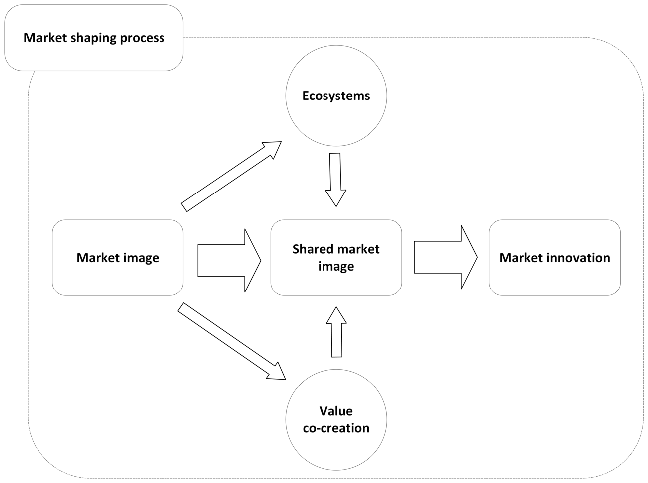
Figure 1. Theoretical framework of the thesis.

The theoretical framework in Figure 1 implements the market shaping process from market image creation, through ecosystems and value co-creation to shared market image creation, and finally to market innovation. According to Nenonen and Storbacka (2020b) forming a scalable vision for the future market is necessary for market shaping. To accomplish this, the market image of a minimum viable solution must be developed. Jaworski et al. (2020) state that next step in the market shaping process towards creating a shared market image is to develop a vision of the ecosystem and articulate the value proposition. According to Nenonen and Storbacka (2020b) to achieve the shared market image among the ecosystem, value must be quantified and communicated, actors must be invited to participate and changes in market-level properties must be driven.

According to Storbacka (2019) as a result of market shaping, in market innovation market actors are able to achieve a combination of value innovation, business model innovation, and institutional innovation by managing the engagement of various actors in a contextually delimited manner. Market innovation can be defined as establishing and institutionalizing resource linkages that improve resource density and, therefore, create value for a market.

The theoretical framework of this thesis defines a process to progress from an early phase of market shaping to initiate a comprehensive phase: start from the minimum viable solution to create a market image and form it through ecosystem development and value co-creation to shared market image. The final step is a market innovation phase where business model and future roadmap for scaling up can be developed.

Methodology
This chapter contains the research methodology of the thesis, including explanation and validation of the chosen method. In addition to this, the thesis case is introduced, and the data collection and analysis are explained. The thesis’ validity and reliability are assessed at the end of the chapter.

This research has been conducted in qualitative extensive case research, and the data collection methods are stakeholder interviews and workshops. The case of this thesis, the 4everPack research consists of five use cases within the 13 companies that are involved at the 4everPack project.

Research method
According to Saaranen-Kauppinen et al. (2005, p. 6-7) qualitative research incorporates previous research on the topic, theories, empirical materials, and the researcher's own thinking and reasoning. The aspects that most often characterize qualitative research are data collection methods: interviews, biographies, letters, observation, diaries, utilisation of various cultural products, consideration of researched perspectives; no experimental settings but more of naturalism, discretionary or theoretical sampling, data orientation, no hypothesis; no locked-in presuppositions about the results, research style and presentation of results, researcher position; freedom of choice, imagination, subjectivity and narrativity.

Qualitative research can be characterized by describing and understanding of a phenomenon, and the research of the thesis is qualitative in nature as it intends to gain a comprehensive understanding of the reusable packaging phenomenon (Hirsjärvi et al., 2007). Qualitative research methods are designed to study a broad range of phenomena, and they can be used to address a variety of research issues in a wide range of contexts (Köhler, Smith & Bhakoo, 2022).
Research is conducted under the title of case study in several disciplines, from various starting points and with different objectives. Case studies are more of an approach than a data collection or analysis method. Consequently, it is difficult to define a case study in a single, comprehensive way. Case studies have one, and perhaps the only, consistency in that they examine a one case or more, which definition, analysis, and solution are the main objectives of the study. The method used to select, delimit, and justify the investigated cases is therefore not self-evident or unimportant. (Eriksson & Koistinen, 2005)

According to Saaranen-Kauppinen & Puusniekka (2006, p. 43) in a case study, a single event, a limited entity, or an individual is investigated using versatile data obtained with different methods. A case study aims to investigate, describe, and explain cases mainly with the help of ‘how’ and ‘why’ questions. According to Eriksson and Kovalainen (2008) it is possible to better understand mundane and changing business practices in their social contexts using case study research.

A case study should be chosen as the approach when one or more of the following conditions are met: 'what', 'how' and 'why' questions are central, the researcher has little control over events, only a little empirical research has been done on the subject, and the object of the research is some phenomenon in contemporary life. (Eriksson & Koistinen, 2005)

The purpose of an extensive case study is to identify common patterns and properties among multiple cases. The method aims to the development, testing, and generation of generalizable theoretical constructs by comparing multiple cases. The focus is not on 'real-life' cases and their detailed descriptions, but the purpose of cases is to examine business-related phenomena and develop theoretical propositions that can be tested and generalized to other business contexts or to theory. (Eriksson & Kovalainen, 2008)

There is no single rule regarding the minimum number of cases that should be selected for an extensive multiple-case research project. It is essential to consider the research objectives and the research questions when choosing the number of cases. Researchers can incrementally generalize their findings by using a multiple-case design. However, researchers must justify why a particular way of defining the cases is useful or reasonable. Determination of the cases can take place either before or after the material collection. If there are more than a few cases, one case cannot be studied as comprehensively as in an intensive case study. In an extensive case study, the cases can be presented in a very limited and precise manner or without detailing the wider operating context. (Eriksson & Koistinen, 2005; Eriksson & Kovalainen, 2008)

The topic of the thesis is to create market images of reusable packaging. The research question is ‘what is the process of the market image creation’, and to get a comprehensive answer to the research question the following research objectives are set; the first objective is to describe the early phase of market shaping through market image and shared market image creation, the second objective is to form a framework for the market image creation and the third objective is to form the 4everPack market images.

The research of the thesis is carried out using qualitative methods by conducting an extensive case study. The thesis is done as part of a research project of the University of Vaasa and the Technology Research Center VTT Oy. The project studies the reusable packaging of Fast-Moving Consumer Goods products. A case study is the best research method for the research in question because the purpose of the research is to form and develop several use cases based on reusable packaging, and to create business models that works for consortium companies. The research examines the phenomenon related to reusable packaging, how disposable packaging could be transformed into reusable packaging, and how the related business models could work at the company level. The research aims to help the change processes of companies toward a more sustainable businesses with the help of researched use cases. The focus of the research is in ‘how’ and ‘why’ reusable packaging would work best from the point of view of material, data, logistics, end user, responsibility, and regulations. It is an extensive case study because the research aims to understand the phenomenon of reusable packaging through multiple use cases and their development.

In case study, the process is diverse and iterative and does not necessarily follow a linear path, but the key steps are formulating the research questions, structuring the research layout, selecting and defining the cases, defining the theoretical perspectives and concepts to be used, clarifying the logic of the dialogue between the material and the research questions, determining the analysis methods, and selecting the reporting method. (Eriksson & Koistinen, 2005)
The challenge of a case study can be diverse set of questions and extensive and versatile material. This can lead to a lack of theoretical concepts, an unclear definition of cases, or an incomplete analysis of the material. (Eriksson & Koistinen, 2005)

Data collection method
According to Hirsjärvi et al. (2007, p.130-131) and Saaranen-Kauppinen & Puusniekka (2005, p. 48) traditional data collection methods in a case study include interviews, observations, exploiting existing materials and participation methods. The choice of data collection method depends on the subject of interest, and it is also possible to choose several methods instead of one to practice triangulation.

Using interviews to collect data is an effective method of gathering valid and reliable information. Researchers use semi-structured interviews to cover a list of themes and questions, which they may vary from interview to interview. Depending on the flow of the conversation, the order of questions can be altered. To explore the research question and objectives further, additional questions may be required during the interview. (Saunders, Lewis & Thornhill, 2016, p. 310-312)

A semi-structured, themed interview requires careful familiarization with the topic and familiarity with the situation of the interviewees, so that the interview can be focused on specific themes. Content and situation analysis is therefore important in a theme interview. The themes to be discussed are chosen based on familiarity with the researched topic. In addition to considering the questions, the selection of the interviewees should also be approached with consideration: the people to be interviewed should be chosen from whom it is thought that the material of the subjects of interest can best be obtained. (Saaranen-Kauppinen & Puusniekka, 2005, p. 56)

In a workshop, data is generated in a very different manner than data that is collected through observation or interview, or from interventions into the participant's current everyday practice. In a workshop, issues are presented, experienced with, played out, and discussed. By utilizing workshops as part of a research design, the researcher creates an immersive and collaborative environment in which meaning is negotiated. The workshop can give participants and researchers the chance to discover new elements at play and the connections between them that may not have been identified before. (Ørngreen & Levinsen, 2017)

The research material of the thesis is collected through stakeholder interviews and workshops. Interviewing is used as a research method in the initial stages of the research with the help of a semi-structured interview framework to find out the wishes, goals, and visions of the companies regarding the project and the use cases. Based on these interviews, the first descriptions of the use cases have been created, which are develop together with the project's stakeholders in the workshops.

Interviews have been chosen as a data collection method since the consortium companies and the people working in them are an active and relevant part of the research project. Based on the study's reference framework, the body of the semi-structured interview is structured around preselected themes.

As the research of the thesis is a collaborative development project between the actors of the ecosystem, it is justified to use a development method that actively involves all the actors to collect the data. For this reason, the ecosystem structure and value propositions are developed together with the ecosystem actors in workshops. The workshops and exercises are developed according to the research objectives, so that they support the development work.
In figure 2 is the overview of the methodological approach of this thesis.

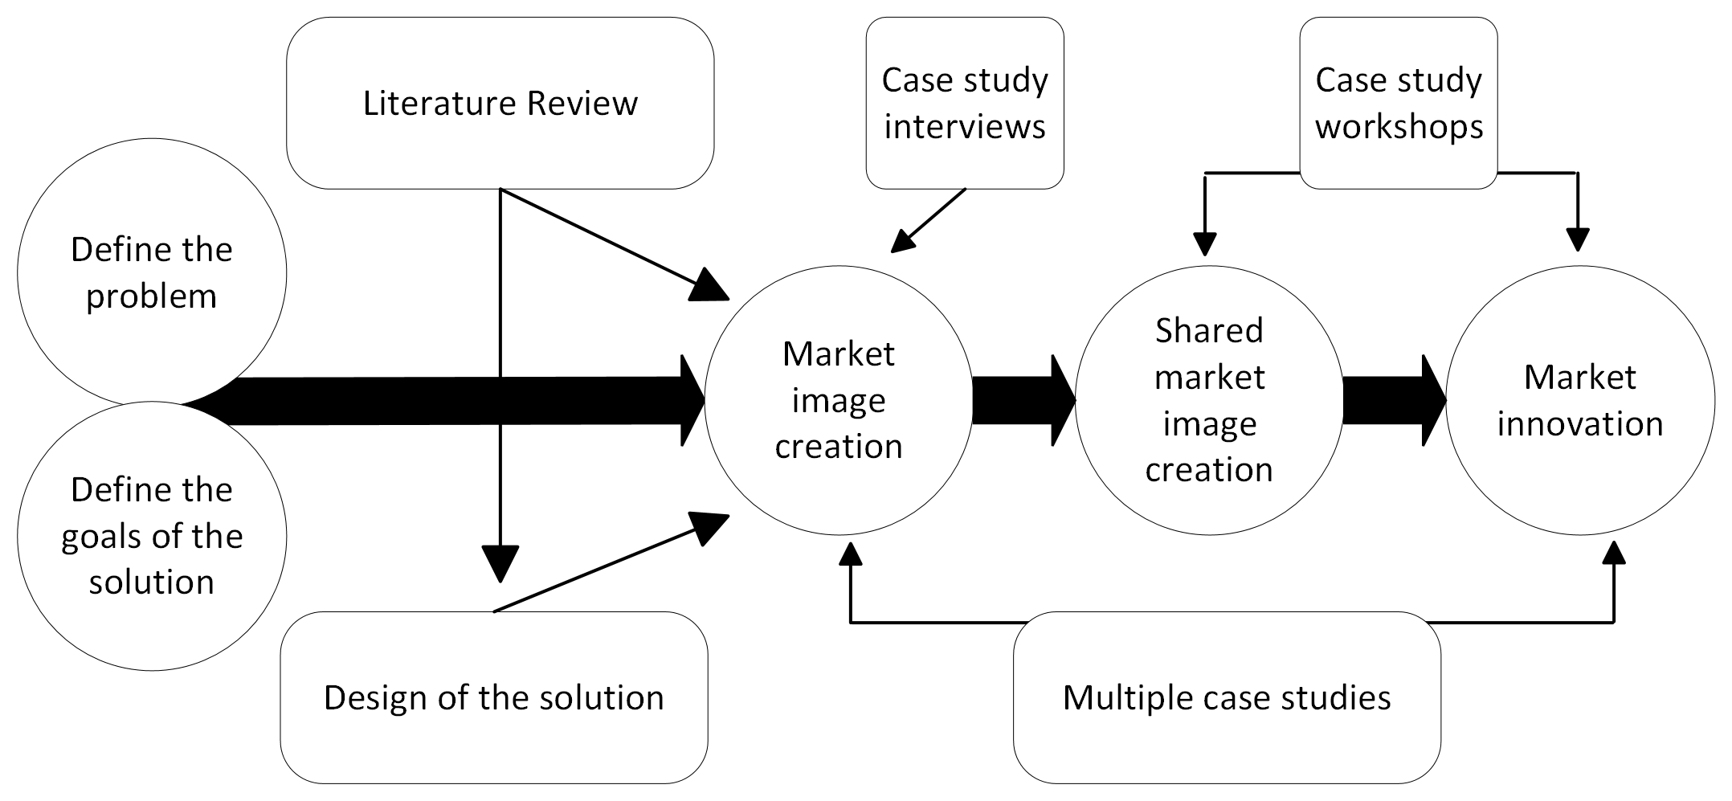
Figure 2. Methodological approach. (Adapted from Bertassini et al. 2021)

Case 4everPack
This thesis is done as a part of the 4everPack project. The project is collaborative research conducted in cooperation with the University of Vaasa and the Technology Research Center VTT Oy. The primary objective of the 4everPack project is to create viable use cases for the reusing of Fast-Moving consumer goods packaging where the package creates value for the customer and the reuse system provides value for the actors in the ecosystem. The project's aims include the ability to preserve and improve packaging functionality while also lessening the need for natural resources and the environmental effects associated with FMCG packaging. (4everPack Project Plan, 2021)

The value chain for future reusable packaging is covered by the 4everPack consortium: from platforms and alternatives for tracking packaging materials, to consumer goods and markets. The consortium actors come together to create a full value cycle that enables combined offers to export markets. (4everPack Project Plan, 2021)

The project work packages and tasks include academic research done in relation to material solutions, packaging monitoring and traceability, logistics solutions, consumer acceptance, and circular business models and roadmap to export markets. This thesis in conducted in collaboration with the circular business model work package, to describe the early phase of the market shaping and market image creation process to shift from single use packaging to reusable packaging business model. (4everPack Project Plan, 2021)

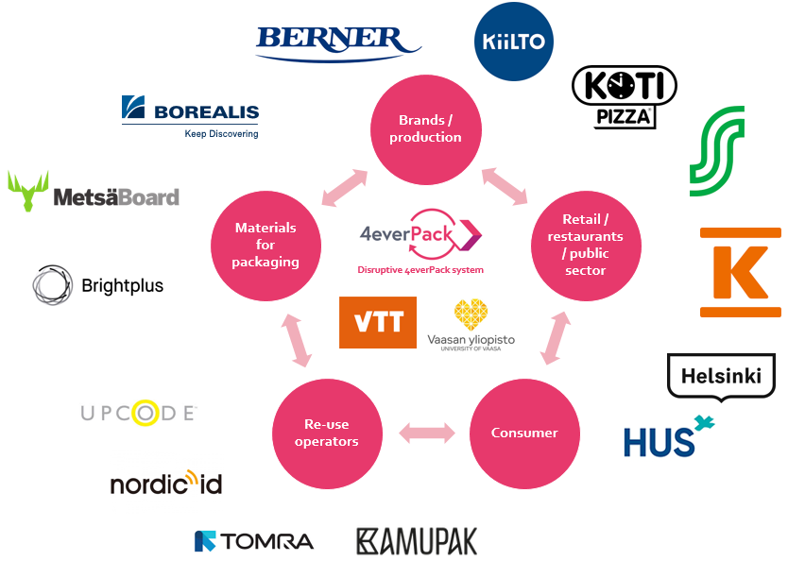
Picture 4. 4everPack consortium. (4everPack Project Plan, 2021)

Data collection
The research interviews were conducted between October and December 2021, and each company in the consortium was interviewed once. The basis of the interviews were the use cases that the companies had pitched in a 4everPack workshop in October 2021 related to FMCG reusable packaging ideas. The objective of the interviews was to gather general information on the initial business idea related to the reusable packaging, and to understand the motivations, past experiences, visions, objectives, and general perception on how the idea could be refined, tested, and implemented in the framework of the project. An interview guide was generated in October 2021 to cover the themes that were to be discussed in the semi-structured interviews, and the following themes were decided on: background of the (reusable packaging) idea and business potential, value chain, collaboration and partnerships, barriers, benchmark and inspiration, user and consumer experiments, and any other business. Questions related to the themes were written down in the interview guide to help start the conversations. Based on the discussions the questions were also elaborated to ask additional and follow-up questions about the topics that came up. The interviews were conducted online in Teams. In Table 1 are the interviewed companies, role of the interviewees, method of implementation and timing of the interview.

Company | Role of the Interviewee | Method of Implementation | Timing
Berner | Packaging Development Manager | Online Interview, Teams | October 2021
Kamupak | CFO | Online Interview, Teams | October 2021
Borealis | New Business Development | Online Interview, Teams | October 2021
HUS &Helsinki | Development Manager, Food Service Specialist | Online Interview, Teams | November 2021
Upcode | Technical Specialist | Online Interview, Teams | November 2021
Brightplus | Sustainability Director | Online Interview, Teams | November 2021
Kesko | Development Manager | Online Interview, Teams | November 2021
Kotipizza | Sustainability Specialist | Online Interview, Teams | November 2021
S-Group | Sustainability Manager | Online Interview, Teams | November 2021
Kiilto | R&D Manager | Online Interview, Teams | November 2021
NordicID | Product Development Director | Online Interview, Teams | November 2021
MetsäBoard | Packaging Services Director | Online Interview, Teams | December 2021
Tomra | Vice President | Online Interview, Teams | December 2021
Table 1. Interviews conducted in the research.

In the second phase of the research the data was collected through stakeholder workshops. The co-creation process conducted two workshops, of which the first workshop theme was ecosystem mapping, and the second workshop theme was value co-creation. The workshops were held between March and April 2022 online in Teams. In table 2 are the co-creation workshop themes, method of implementation and timing for the workshops.

Theme | Method of Implementation | Timing
Ecosystem Mapping  - Stakeholders, roles, activities  - Benefits at actor and ecosystem level  - Challenges and issues | Online Workshop,  Teams and Miro | March 2022
Value co-creation  - Value propositions  - Pains and Gains  - Touchpoints | Online Workshop,  Teams and Miro | April 2022
Table 2. Workshops conducted in the research.

Data analysis
Case studies can be analysed using all qualitative research analysis methods. Researchers have developed analytical methods that are well suited to case studies. It is important to choose the most appropriate analysis method for the research material and the research question. Case studies frequently use a variety of general methods such as classifications, categorizations, typifications, analyses, and thematizations. (Eriksson & Koistinen, 2005)

This research analysis in conducted using content analysis. Using Eriksson and Kovalainen's definition (2016, p. 119-121) of content analysis, the researcher emphasizes what has been done and what has been said in the data. An important component of content analysis is reducing the material to make it as concise and clear as possible without losing its internal information. A clear picture of the scattered material is sought in the research, so that conclusions can be drawn from it.

The content analysis began with taking notes and transcribing the interviews. With the transcribed material, the main features of each interview were collected by interview themes. This material was used to assemble compatible market images of the reusable packaging, use cases, and companies needed for the cases. A preliminary plan was created for the use cases and their actors, and the market images were co-created further to shared market images at the workshops.

Validity and reliability of the study
Research reliability is determined by the terms validity and reliability. Validity refers to a research method's ability to measure the purpose for which it was intended. Based on the research purpose and the research questions, validity indicates how well the research is able to answer them. Reliability refers to how the research method is able to produce repeatable results, how well it is suitable for solving the research problem, and how predictable the results are. (Hirsjärvi et al. 2007, p. 226–228)

There are also four concepts that can be used to assess the reliability of qualitative research: dependability, credibility, transferability and conformability. Dependability is a measure of the researcher's ability to attach the research findings to the research material. The term transferability refers to generalizability, is it possible to transfer the research results to another context. Credibility refers to whether the research results are credible. Confirmability refers to whether the research findings can be confirmed. (Moisander & Valtonen, 2006)

A case study has often been criticized for not being able to yield statistical generalizations. A case study cannot produce statistical generalizations based on just one or a few cases, and that is not its purpose. A case study can produce theoretical generalizations, but its primary purpose is to provide detailed and precise information about the researched topic through cases. Understanding the case itself is therefore essential. The development of theory in case studies typically involves the systematic comparison of several cases. (Eriksson & Koistinen, 2005)

Findings
In the fourth chapter of the thesis, the implementation and results of the research are analysed and reviewed. The results of the interviews and workshops and 4everPack project use cases are interpreted with help of the theoretical reference framework formed in the research.

4everPack market images

Interview findings
The 4everPack project interviews were conducted between October and December 2021. The initial situation with the project at the start of the interviews was that the consortium companies had represented their first ideas for the FMCG reusable packaging related to their business areas, and the aim for the interviews was to trace the origins of the ideas, understand the vision and motivations behind them and get information about business opportunities related to the cases.

The initial use case ideas were reusable bottle packaging for detergents, reusable sales unit or transport packaging, reusable takeaway food and pizza packaging, reusable e-commerce packaging, reusable grocery home delivery packaging, reusable bag in a box -packaging, and food delivery system for hospital based on reuse. The interview themes for the semi-structured interviews were background of the packaging idea and business potential, value chain, collaboration and partnerships, barriers, and benchmarking. The discussions in the interviews were focused on the use cases, the actors needed for the ecosystem, what value the packaging would produce, and what are the barriers and possibilities that the consortium companies have regarding the packaging solutions.

After the interviews the main points regarding each use case were gathered to be analysed together with the project researchers. The main points from the interviews for each use case are summarized in table 3.

Use case | Actors | Drivers | Barriers/challenges | Other relevant topics
Reusable bottle packaging for detergents | New operators needed for returning and washing. | Sustainability.  Regulations.  Customer needs. | Regulations on detergent packaging. | Environmental impacts – is it better solution than recyclable packaging.  What is the content of the packaging.
Reusable sales unit/transport packaging | New operators needed for sanitizing. | Sustainability.  Cost savings. | Solutions (meat boxes etc.) already existing.
Reusable takeaway food/pizza packaging | Existing washing and logistics infrastructure in stores exploited - decentralized model for washing and logistics.  or  Centralized washing. | Sustainability.  Current solutions expensive.  Regulations.  Consumer needs and engagement.  Extension of the solution to other actors. | Infrastructure.  Price.  Storage.  Packaging design.  Regulations on food packaging and return transport.  Quality of the pizza in reusable packaging. | For the regulations to be put into effect there needs to be existing solutions to replace the single use packaging.
Reusable  e-commerce packaging | New operators needed for (possible) sanitizing. | Sustainability.  E-commerce is a growing segment.  Regulations. | Material durability.
Reusable grocery home delivery packaging | New operators needed for sanitizing. | Sustainability.  Home delivery is a growing segment. | Material durability. | Environmental impacts – is it better solution than recyclable packaging.  Collection needs to be convenient to the consumer.
Reusable bag in a box -packaging for detergents. | Washing/sanitizing operator needed. | Easy to test. | Regulations on detergent packaging.  Washing.  Labeling.
Food delivery system for hospital based on reuse | New operators needed for returning and washing – outsourced services. | Sustainability.  Scalability.  Regulations.  Outsourced washing lessens the hospital resource needs. | Consumer motivation.  Packaging hygiene.  Different food conditions.  Packaging design. | Material losses should be controlled.  Consumers only care about convenience – system cannot be owned by the consumer.  Reuse system should eliminate the single use system.
Table 3. Interview findings.

Use cases
After the research interviews were completed and the findings were put together, the use cases were evaluated in December 2021 based on the interview material. For each use case the description of the solution, actors needed for the ecosystem and challenges of the case were outlined and analysed. Based on the analysis five use cases were selected for the project: food delivery system for hospitals, reusable takeaway food packaging, reusable grocery home delivery package, reusable bottle packaging for detergents, and reusable takeaway pizza packaging. The five use cases combined the previously introduced initial ideas, and all of the consortium companies had interests, capabilities and needs for the use cases. The selected use cases were feasible with the actors of the 4everPack consortium, and they were validated by the consortium in January 2022. In the following chapters the use case overviews and participants are introduced. The use cases serve as market images of reusable packaging for the 4everPack project.

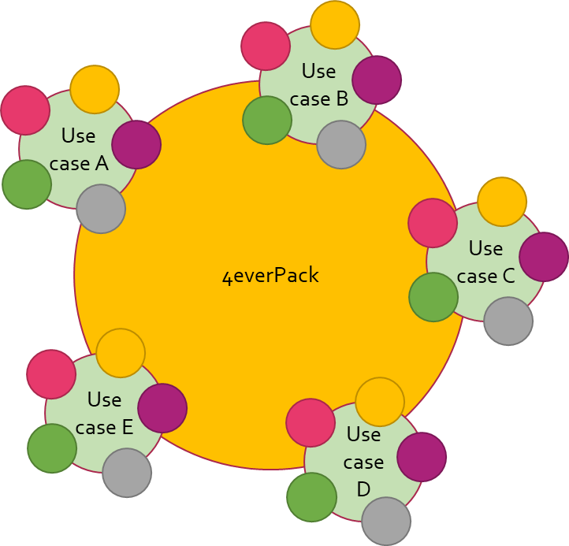
Picture 5. 4everPack use cases.

Food delivery system for hospitals
The use case focuses on hospital catering based on reusable packaging. The solution will reinvent the hospital catering process to reduce waste reduction and help meet the city and nationwide circularity goals.​

In the solution the food is packed in centralized kitchens to dose boxes, delivered and heated at the hospital, and brought to the patient. After the patient has eaten, empty boxes are collected from the hospital by logistics partner, washed by outsourced washing partner and delivered back to the centralized kitchen by logistics partner. ​

Use case A – Food delivery system for hospitals
HUS & Helsinki company lead
Kamupak overall service provider
Borealis material producer and packaging designer
NordicID and Upcode tagging solutions
Brightplus active learner
MetsäBoard active learner
Logistics and washing solutions to be developed from outside the consortium
Table 4. Use case A actors.

Reusable takeaway food packaging
The use case focuses on a reusable packaging solution for takeaway and ready-to-eat meals in retail store service counters and restaurants. The solution is a reusable packaging for different types of foods to reduce the environmental impact and use of plastic materials. The long-term objective is to build a system that responds to the consumers needs extensively and enables nationwide waste reduction. ​

In the solution the food is packed to dose boxes at the service counter or at the restaurant, returned to the store by customer after use, collected by logistics partner, washed by outsourced partner, and returned to the location by logistic partner. ​

Use case B – Reusable takeaway food packaging
S-Group company lead
Kamupak overall service provider
Borealis material producer and packaging designer
(Brightplus coatings)
NordicID and Upcode tagging solutions
Tomra returning solutions
Kesko active learner
Logistics and washing solutions to be developed from outside the consortium
Table 5. Use case B actors.

Reusable grocery home delivery package
The use case focuses on a reusable packaging solution for online grocery stores. With reusable packaging the online grocery shopping use of raw materials is decreased, and less packaging waste is produced. The long-term objective is built a nationwide system that is based on retail store networks. ​

In the solution the groceries are packed into reusable boxes at the store and delivered to and collected from consumers by logistics partner. Logistics partner also delivers the package to sanitizing for outsourced washing partner and returns the box to the store after cleaning. ​

Use case C – Reusable grocery home delivery package
Kesko company lead
MetsäBoard material producer and packaging designer
NordicID and Upcode tagging solutions
S-Group active learner
Logistics and washing solutions to be developed from outside the consortium
Table 6. Use case C actors.

Reusable bottle packaging for detergents
The use case focuses on a reusable bottle packaging that is used for b2c cleaning products. The solution reduces the need of virgin or recycled material and helps to lower the brand owners overall carbon footprint.

The reusable bottle packaging for detergents has two possible scenarios. In scenario 1, the brand owner packs the product, and logistics partner delivers the product to the retail store for selling. After usage consumer returns the bottle to the store into a returning machine, and logistics partner delivers the package into outsourced washing and returns the bottles to the brand owner.​ In scenario 2, the brand owner packs the product, and logistics partner delivers the product to the retail store for selling. After usage consumer washes the bottle and brings it to the retail store to fill the empty bottle through refill dispenser. Consumer pays for the refill, uses the product and the loop is repeated for multiple cycles until the packaging is unfit for reuse and is collected for recycling.

Use case D – Reusable bottle packaging for detergents
Berner company lead
Kiilto company lead
Brightplus material producer and packaging designer
Upcode and NordicID tagging solutions
Refill solution to be developed from outside the consortium
Logistics and washing solutions to be developed from outside the consortium
Table 7. Use case D actors.

Reusable takeaway pizza packaging
The use case focuses on reusable takeaway pizza packaging that is used at the brand owners’ restaurants. The solution enables a reduction on the use of packaging materials and lowers the brand owners overall carbon footprint. ​

In the solution the pizza is packed into a reusable packaging at the restaurant. Consumer uses, washes, and stores the packaging at home. After usage consumer brings the packaging into the restaurant when picking up a new ordered pizza.

Use case E – Reusable takeaway pizza packaging
Kotipizza company lead
Kamupak overall service provider
Borealis material producer
Upcode and NordicID tagging solutions
Packaging design outside the consortium
Logistics and washing solutions to be developed from outside the consortium
Table 8. Use case E actors.

4everPack shared market images
In the second phase of the research the ecosystem and value co-creation workshops were designed and executed. The purpose of the workshops was to create a shared market image of the reusable packaging in the 4everPack context, through developing and co-creating the use cases further with the actors. The workshops were held from March to April 2022 and each of the use cases had their own set of workshops. The workshop participants were the ecosystem actors in the 4everPack consortium. The workshops were held online in Teams and the exercises were executed in Miro.

Ecosystem workshop
The ecosystem workshop objectives were to understand which actors should be part of the ecosystem, clarify the roles, activities, resources and expected benefits of each actor, characterize the value flows between each actor and point out missing actors and emerging issues.

The first workshop exercise was to define the ecosystem goal, for which the participants filled an exercise card for one line business model pitch to clarify what the offering in the ecosystem is: what is the purpose, who it is for, and what needs to be achieved for the solution to be done.

The second exercise in the workshop was to map the ecosystem. First the main phases of the value chain were pointed out, and then the ecosystem actors put their organisations and activities into the chain. The purpose was to get a shared understanding of the roles and activities in the ecosystem, who implements the needed functions and what actors are missing from the ecosystem value chain. For 4everPack reusable packaging value chain the general framework and needed actors for the ecosystem are raw material producer, packaging designer, packaging manufacturer, production, distribution, retail, and user, from who the packaging goes into reuse loop which involves collection, washing, redistribution, and from the reuse loop the packaging goes back to retail and user until it is unfit for usage and goes to recycling as waste.

The third exercise of the ecosystem workshop was to characterize the stakeholders. All the participants filled an actor card for their organization and activity in the ecosystem, to clarify their role in the value chain further. The filled sections were role and purpose in the ecosystem, activities, resources and capabilities, and expected benefits from joining the ecosystem.

The fourth exercise of the workshop was to clarify and bring out issues and challenges in the ecosystems. The objective was to write down what assumptions there are that need to be validated for the ecosystem to develop.

The fifth and final task of the workshop was to write down questions about the ecosystem and the use case related to materials, logistics, data, consumer acceptance, business profitability, and sustainability. The topics were then researched and worked on by University of Vaasa and the Technology Research Center VTT Oy researchers.

Value co-creation workshop
The value co-creation workshop objectives were to refine the journey of the solution to identify main touchpoints and possible obstacles to overcome, clarify the business model value proposition through analysing benefits associated with the ecosystem and user perspective, draft a storyboard detailing the interaction between the solution and end user, and identify further issues related to the ecosystem and value co-creation.

The first exercise of the workshop was to create a solution journey to refine the different steps for the implementation of the solution, and to clarify individual tasks within the ecosystem actors. The first exercise was done by the researchers before the workshop based on the ecosystem workshop exercises and discussions. The purpose was to develop the ecosystem further, and kickstart the value co-creation workshop with a joint understanding of the shared market image to bind the workshops together and further co-create the value the solution produces.

The second exercise was to fill out a value proposition canvas for the solution. The participants roughly described the solution and its features, clarified the job that the solution does, described what gains it can provide and what pains it can relieve, and highlighted the drivers and challenges of the solution.

The third exercise was to create a user storyboard for the solution. The participants filled out touchpoints that the user has with the packaging, described actions that are done, and who, where and what takes place in the touchpoints.

The fourth exercise of the workshop was to clarify and bring out issues and challenges in the value creation. The objective was to write down what assumptions are needed to be validated for the solution and its value creation to develop.

The fifth and final task of the value co-creation workshop was to write down questions that are remaining related to the use case and its ecosystem value creation. The questions were written down under the research work package topics: materials, logistics, data, consumer acceptance, business profitability and sustainability.

Use case workshops
In this chapter the workshop exercise outcomes for each of the 4everPack use case are reviewed. The exercise results and the workshop discussions are summarized in order to describe the outcomes in an understandable form.

Food delivery system for hospitals workshops
In the ecosystem workshop the first task was to define the overall ecosystem goal. The food delivery system for hospitals use case ecosystems main offer is a system that enables a safe and effective reuse of food packaging in hospital environment. The goal is to reduce packaging waste and lessen the environmental impacts of hospital food services. This will be done by allowing patients to get access to food in reusable packaging by developing a packaging that meets the criteria for the specific environment.

The second aim of the workshop was to position the ecosystem stakeholders into a value chain map to characterize the needed and missing actors. The value chain for the use case food delivery system for hospitals can be seen in Picture 6.

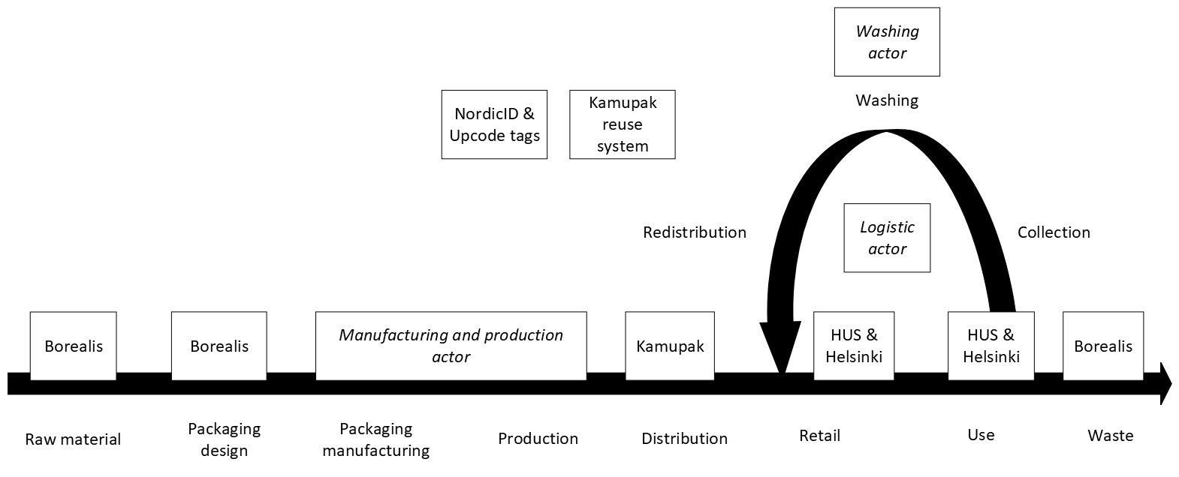
Picture 6. Food delivery system for hospitals value chain.

In the value co-creation workshop the main task was to fill a value proposition canvas to refine the benefits associated with the solution. In the workshop there were two perspectives taken, the hospital as a customer and the patient as the end user, and from those perspectives the customer jobs, pains and gains were defined. The results can be seen from table 9.

Customer job(s) | Gains | Pains | Implications for the 4everPack project (what is needed to ensure the gains and overcome the pains)
HOSPITAL: Access a waste free food distribution service. | Reusable packaging system responds to the Helsinki region circular economy goals and is expected to offer more efficient food distribution than the system used in today.  One action more in sustainability action plan.  Forerunner in sustainability. | Investment costs.  Personnel has to learn to adapt into a new reverse logistics. | A cost-efficient, easy to adapt solution.
HOSPITAL: Better tracking and monitoring tools for the food served. | Hygiene chain, temperature information to track the possible problems in the chain, from which patch the food is from etc.  Benefits of tracking: right food, right time, right place. | Investment costs.  Personnel need to learn how to use the tools necessary for package monitoring. | A cost-efficient, easy to adapt solution.
HOSPITAL: Food and packaging are adapted to patient needs. | Solution that enables customization.  Reduces the food waste as the variety of food can be greater than in the current system. Serves more diets and ensures patients get the food they want to eat.  Solution that is lighter to handle.  Superior functionality of the packaging in comparison to conventional plate (e.g. separation of the foods, keeping food warm). | Investment costs.  Hygiene concerns. | A cost-efficient system, that ensures the food safety through washing and tracking of the packaging condition.
PATIENT: Knowing what’s on the plate (origin, etc.). | Food and packaging as part of better customer experience. | Possible added costs.  Digital literacy required. | A cost-efficient, easy to adapt solution with alternative options for usage (personnel help etc.).
PATIENT: Eating in a way that doesn’t create waste. | Eating "sustainably" may provide moral satisfaction, thus increasing total subjective well-being. | Unknown safety risks. | A full circular system, that ensures the food safety through washing and tracking of the packaging condition.
PATIENT: Eating food adapted to diet and preferences from a packaging that fits the needs. | Food and packaging as part of better customer experience evaluation.  Food that stays hot longer time than when served on a plate. | Package is more difficult to handle, such as opening the package lid.  The patient does not see any difference to the conventional plate. | A functional packaging design, that ensures the added value to patient through more customized service.
Table 9. Food delivery system for hospitals value proposition canvas summary.

The interaction steps that the patient has with the solution are: patient provides information about his or her diet, patient is served food by an orderly, patient eats the food from the packaging, patient receives additional info on food content and amount of emissions reduced, and patients’ packaging is collected by orderly.

The key challenges, questions and topics of the use case related to the 4everPack work packages are to identify the key features of the packaging and its design, find possible logistics and washing operators and do logistics modelling, form a data solution plan, identify the possible needs and requirements from the end user perspective, and form an overview of the costs.

Reusable takeaway food packaging workshops
The overall ecosystem goal for reusable takeaway food packaging use case is to offer a reusable, sustainable solution to customers for their takeaway food in order to reduce packaging waste. This will be done by allowing the end users conveniently enter and exit a reuse scheme with a network of service providers.

The value chain formed at the workshop for the use case can be seen in Picture 7.

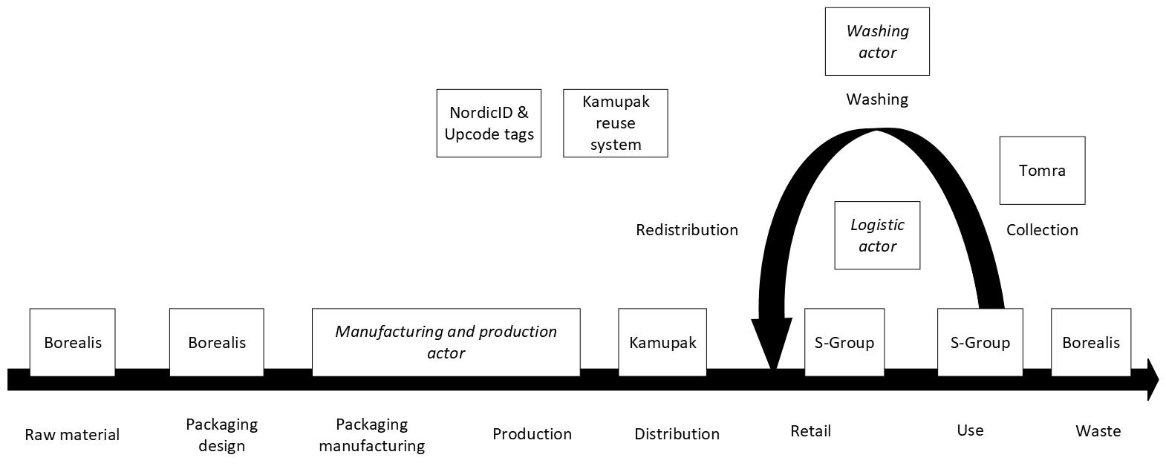
Picture 7. Reusable takeaway food packaging value chain.

The value proposition canvas for the takeaway food packaging is summarized in table 10.

Customer job(s) | Gains | Pains | Implications for the 4everPack project (what is needed to ensure the gains and overcome the pains)
Takeaway food packed in a sustainable and waste free manner. | Environmentally well performing packaging solution.  Possibility to avoid single use and reduce waste.  No packaging waste to dispose of.  Information through data about sustainability, avoided waste and reduced co2 emissions.  Feeling good about themself after using more sustainable service. | More expensive than single use packaging. | A cost-efficient, easy to use and environmentally assessed solution.
Takeaway food that is packed in a solid, safe and hygiene manner. | Easy return.  Cheaper than single use packaging  - zero cost for consumer  Incentives, rewards such as discounts, deposit etc.  Good quality packaging  - microwave safe  - cold or hot portions of food | Package return  - Inconvenient return locations  - Need to carry the package to return point  Package storage  - Pre-cleaning the packaging before the return  Food safety concerns  - If the packaging condition is not optimal, it might seem non-hygiene | A functional packaging service and logistics design that ensures the packaging safety.
Table 10. Reusable takeaway food packaging value proposition canvas summary.

The interactions steps that the end user has with the solution are: end user buys or orders food and receives it in a reusable packaging, user pays the food in the packaging, user brings the packaging home, user eats the food from the packaging, user stores the empty package, user brings packaging back to a dispenser in a store or restaurant, and user receives information on an app about the packaging, such as saved emissions and materials and possible discounts.

The key topics and challenges of the use case are to identify the logistics and washing operators, design the logistics model, evaluate the data needs and align them with the technical solutions, and calculate the costs of the system.

Reusable grocery home delivery package workshops
The overall ecosystem goal for the use case is to offer an environmentally and economically sustainable reusable grocery home delivery packaging. The aim is to cut down the increasing material demand and reduce waste production.

The ecosystem value chain for the reusable grocery home delivery package can be seen from picture 8.

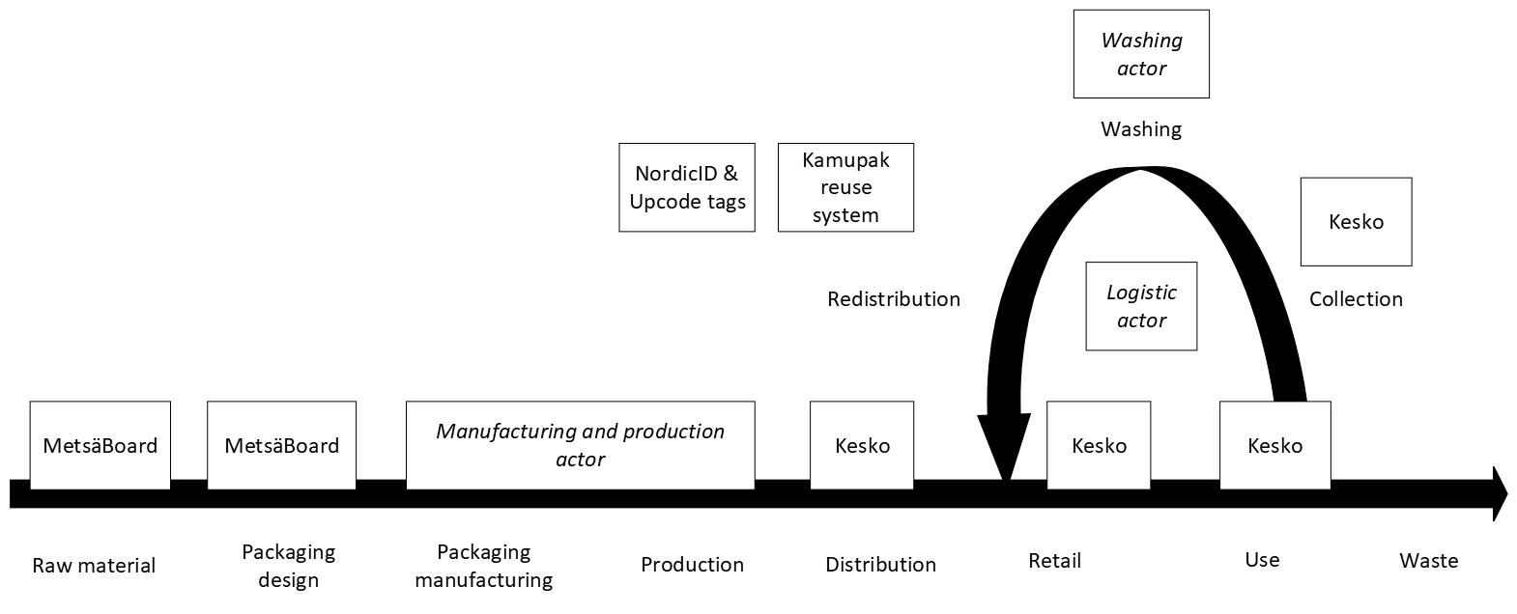
Picture 8. Reusable grocery home delivery package value chain.

The value proposition canvas for the reusable grocery home delivery package is summarized in table 11.

Customer job(s) | Gains | Pains | Implications for the 4everPack project (what is needed to ensure the gains and overcome the pains)
Groceries received in a sustainable, waste free manner. | Signalling others that the user is a forerunner in using (sustainable) innovations.  Recognition from others and feeling good about themselves for adopting sustainable services.  Sense of quality through the packaging made of high-quality materials. | Quality of the pre-selected perishables.  Potentially narrower selection options. | A cost-efficient, easy to use and environmentally assessed solution.
Products received intact and in good hygiene. | More data-based solutions (e.g. temperature monitoring, hygiene evaluation, condition monitoring) | Hygiene concerns.  Condition monitoring effectivity.  Customer responsibility for the washing and condition monitoring. | A cost-efficient system, that ensures the packaging hygiene through sanitizing and tracking of the packaging condition.
Usage of the easy-to-use, hassle-free deposit system. | More customer solutions (e.g. by utilizing AI)  Rewards and other incentives for using reusable.  Convenience.  Cheaper price.  Different sizes available.  Boxes don’t fall apart as easily.  Fast product processing. | Data privacy issues.  Return logistic convenience.  Storage.  Higher price.  Too high deposit.  Large purchases = more boxes to store (might be an issue since online grocery purchases are usually larger than when visiting a store). | A functional packaging service and logistics design, that ensures the added value to customer through more customized service.
Table 11. Reusable grocery home delivery packaging value proposition canvas summary.

The interaction steps that the end user has with the solution are: user orders groceries online, the order is delivered in a reusable packaging, user stores the packaging at home, user goes to store and returns the reusable packaging or delivery person picks up empty packaging when delivering a new order, and user receives information about the waste reduction, emissions saved and possible discounts.

The key topics and challenges related to the use case are to design the packaging, identify local logistics, sanitizing and storage networks, evaluate the data needs and desires, review if the reusable packaging solution is more sustainable than the current single-use solution, and form an overview of the costs of the solution.

Reusable bottle packaging for detergents workshops
The aim for the detergents use case is to offer a reusable, sustainable packaging for detergents in order to reduce the use of virgin materials in packaging. The goal is to allow end users reduce waste by developing a system that enables the packaging to be collected, washed, refilled, and used again. The use case has two possible scenarios, scenario 1 being return of the bottle and scenario 2 refill of the bottle.
The ecosystem value chain of the reusable bottle packaging for detergents can be seen from picture 9.

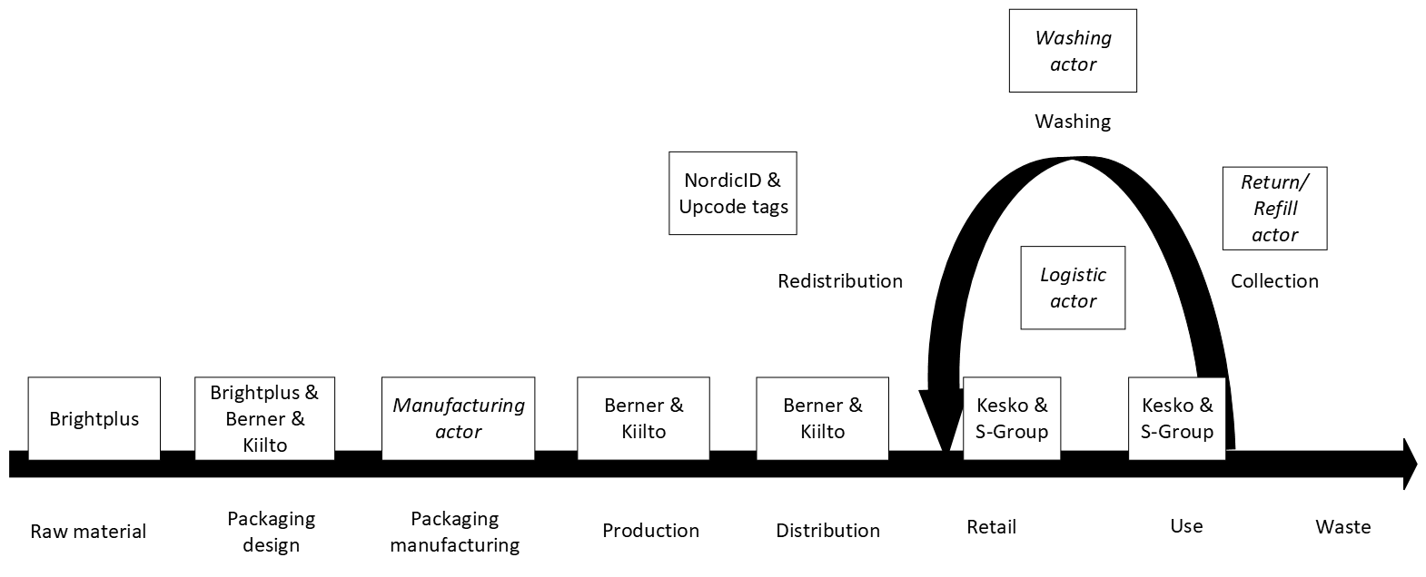
Picture 9. Reusable bottle packaging for detergents value chain.

The value proposition canvas for the reusable bottle packaging for detergents is summarized in table 12. Both the return and refill scenarios are placed in the table.

Customer job(s) | Gains | Pains | Implications for the 4everPack project (what is needed to ensure the gains and overcome the pains)
Easy access to detergents. | Cheaper retail price for bringing back the bottle.  Desired product inside the reusable bottle. | REFILL:  How to use a refill station.  Forgetting the refillable bottle – costs to get a new one.  Having to go to specific stores to refill the bottle.  Ensuring that the dosing is correct and safe.  RETURN:  How to return the bottle.  Having to take the package back to return point.  BOTH SCENARIOS:  The amounts of brands and products might be limited.  Storage of the empty bottles.  Knowing the bottles end-of-life.  Bother to rinse or wash before refill or return. | A cost-efficient, functional packaging service and logistics design, that ensures the added value to patient through more customized service.
Waste free solution for detergents. | Feeling good about themselves when considering the environment and reduce waste.  Information about how much waste and co2 emissions are avoided with the solution. | The return loop and logistics added environmental costs.  Solution hygiene and safety. | A cost-efficient, easy to use and environmentally assessed solution.
Table 12. Reusable bottle packaging for detergents value proposition canvas summary.

The interaction steps that the end user has with the return scenario are: user buys reusable, filled bottle from the retail store, user uses the detergent at home, user returns the bottle to return machine, user gets deposit on an app, user uses the deposit for the next purchase. The interaction steps with the refill scenario are: user goes to refill dispenser in a retail store and picks up an empty bottle, user fills the bottle from the dispenser, user pays for the bottle and the detergent, user uses the detergent at home, user rinses and stores the empty bottle, user goes to the retail store and refills the bottle, and when the bottle is end-of-life, user returns the bottle and gets deposit back.

The main topics and challenges related to the use case are to review between return and refill scenarios, find a return or refill actor for the ecosystem, identify possible logistics and washing operators, design the packaging and decide its suitable content, evaluate the data needs and align them with the technical solutions, and form an overview of costs and benefits of the solution.

Reusable takeaway pizza packaging workshops
The overall ecosystem goal for the use case is to offer a sustainable, reusable takeaway pizza packaging in order to reduce the environmental impact of the packaging. This will be done by allowing the consumer to choose environmentally friendly solution by offering a reusable option for the takeaway pizza packaging.

The reusable takeaway pizza packaging value chain can be seen from picture 10.

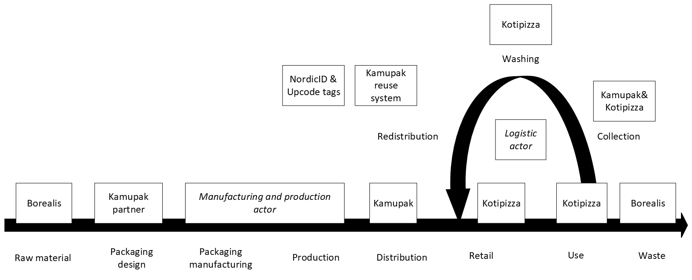
Picture 10. Reusable takeaway pizza packaging value chain.

The value proposition canvas for the reusable takeaway pizza packaging is summarized in table 13.

Customer job(s) | Gains | Pains | Implications for the 4everPack project (what is needed to ensure the gains and overcome the pains)
Takeaway pizza packed in a sustainable and waste free manner. | Environmentally beneficial packaging solution.  A waste free service.  End user can easily do their part in moving towards waste-free consumption.  Responsible choice according to the end users’ values. | Is the solution more sustainable than the current cardboard solution. | An easy to use and environmentally assessed solution.
Takeaway pizza packed in a new, easy, and effortless way | Better quality packaging.  Price benefits.  Incentives (deposit, discount, offer, information etc.)  Smart and connected packaging. | Trouble of storing and transporting the packaging for return.  Possible need for washing.  More expensive.  Need to learn a new concept.  Hygiene concerns.  Food quality concerns. | A cost-efficient, functional packaging and logistics design, that ensures the Added value to patient through more customized service.
Table 13. Reusable takeaway pizza packaging value proposition canvas summary.

The interaction steps that the end user has with the solution are: user orders a takeaway pizza and chooses reusable packaging option, user pays for the pizza and the packaging, the pizza is home delivered or the user carries the pizza home from the restaurant, user eats the pizza, user washes and stores the packaging, package is picked by a delivery person during the next delivery or user returns the packaging to restaurant, and user receives information about their impact on environment by choosing the reusable option and possibly a discount.

The key topics and challenges related to the use case are to assess whether the reusable takeaway pizza packaging is a more sustainable solution than the current cardboard packaging solution is. In addition, consumer acceptance of the solution should be studied, and experiments with the pizza packaging solution should be done to evaluate the packaging properties. The data needs and technical solutions should be aligned, and costs and benefits of the solution reviewed.

Conclusions and discussion
In the last chapter of the thesis the research conclusions are reviewed and suggestions for further research are discussed. The purpose of this thesis was to address the early market shaping process through market image creation of the 4everPack research project. In addition, the aim was to create the market images of reusable packaging in the 4everPack context. To achieve this, the research questions was ‘what is the process of market image creation’.

Main findings
The purpose of the thesis and the research question were answered through three research objectives. The first objective was to describe the early phases of market shaping through market image and shared market image creation. The objective was described and answered in the theory chapter. In the theory chapter market shaping was introduced, and market image creation was described as a way to shape the market in an early phase to get the company or the ecosystem to move in the right direction. As the reality of today’s market is networked and innovations are often formed through the co-operation of ecosystems, the next phase for market shaping is to get the market image into shared market image among the ecosystem. This can be achieved through co-creation of the ecosystem and its values, as is described in the theory chapter.

The second objective was to form a framework for the market image creation process. The objective was answered at the last theory chapter and put into practice at the empirical part of the thesis. The theoretical framework described the market shaping process from market image creation, through ecosystem and value co-creation to shared market image creation, and finally to market innovation. The market image and shared market image creation are key to early phase of market shaping because through them the scalable vision of the solution, participation in the ecosystem development and common understanding of the value creation are formed. The market innovation phase is not described in this thesis, but it would be the next phase of market shaping to get the market image into realized market innovation. In the market innovation phase, the business model and future roadmap for scaling up would be developed.

The third objective of the thesis was to form the 4everPack market images. The 4everPack use cases act as the market images of reusable packaging. The starting point for the market image creation was to define the problem, which is the ever-increasing plastic pollution, and define the goal of the solution, which is to lessen the plastic waste and decrease the pollution by transforming the single-use FMCG packaging into reusable packaging. The research started with literature review to design the theoretical basis of the solution, and continued with semi-structured, themed interviews to form the first images of the possible reusable packaging use cases. The use cases were developed into the first market images that were then deepened and detailed in the co-creation workshops. The end results after the workshops were descriptions of the goals of the use cases, ecosystem value chains, and value propositions canvases. The main challenges and issues of the use cases were also discussed and collected so that they can be developed further in the next steps, to get the market images realized into market innovations.

Suggestions for further research
The future research could focus on the main challenges and topics that emerged in this research, as the aim is to get the use cases developed further into business models. The main challenges varied between the cases, but there were common themes that were recognizable from all or most of the cases. The project consortium lacked the logistics, washing and packaging manufacturing operators, so they were missing from all of the ecosystem value chains and need to be identified outside the consortium for the solutions to work. For the use cases grocery delivery packaging and takeaway pizza packaging, the current solutions are made of cardboard, and the environmental impacts are quite low, so a life cycle assessment should be done to ensure that the reusable packaging is be a more sustainable solution. Because the solutions have reverse logistics and washing, confirmation that the reusable packaging is a better and more sustainable solution should be obtained for all the cases. Also, the costs and benefits calculations should be done so that the solutions are justified to be moved forward into the realization phase. The data solutions should be developed into stage that the packages can be tracked, identified, assessed, and they can bring users added value by providing information and engagement opportunities. The consumers’ concerns regarding usage, storage and hygiene should be eliminated by developing the solution in a such way that the issues cease to exist. This requires a functioning system where all the ecosystem actors work together in every step of the process.

To develop the solutions and solve the challenges, the use cases could benefit from small experiments. For example, consumer studies, small experiments with existing packaging, surveys, and usage schemes can help to assess the steps of the system and develop the solution further. This requires participation from the ecosystem actors. Rapid experiments are a step toward realization of the market images into market innovations. To turn the solutions into fully functioning business models, larger scale pilots, testing and road maps for future are also favorable. The further research could focus on the phase where the market images are developed into realized market innovations through further development, experiments, and pilots. For the solutions to shape the market, they should be good enough to make single-use packaging unnecessary in a large scale to achieve the packaging market change and pollution reduction.

Limitations of the research
The 4everPack project is a multi-case study and it aims to bring a solution to the universal FMCG packaging waste and pollution problem. Since the research involves certain companies, their products and packaging, it reduces the generalizability and reproducibility of the research in other contexts. In addition, in a multi-case study it is not possible to research as thoroughly the cases as in a single case study. The research has also been carried out on the condition of the companies participating in the research, to create use cases that can be implemented and converted into business models. As a result, use case participants and ecosystems are built based on available companies, and some actors are completely absent from the research consortium.

The 4everPack research is conducted between September 2021 to September 2023. This thesis research is conducted from October 2021 to May 2022, and the main research continues further. This thesis is done as a part of the work package related to circular business models, and the other work packages work is not included in this thesis.

In on the research, however, a process was found for the early phase of market shaping. The process was implemented in the context of the 4everPack research, creating the use cases as market images of reusable packaging. In the research, use case ecosystems were formed, and value propositions and general challenges related to the reusable packaging use cases were found.

References
Aarikka, Stenroos, L., Ritala, P. & Llewellyn, D.W.T. (2021). Circular economy ecosystems: a typology, definitions, and implications. Research Handbook of Sustainability Agency, 260-276. Edward Elgar Publishing. https://doi.org/10.4337/9781789906035

Adner, R. (2006). Match Your Innovation Strategy to Your Innovation Ecosystem. Harvard Business Review, 84(4), 1-12. Retrieved 2021-12-13 https://hbr.org/2006/04/match-your-innovation-strategy-to-your-innovation-ecosystem

Baker, J. J., Storbacka, K. & Brodie, R. J. (2019). Markets changing, changing markets: Institutional work as market shaping. Marketing Theory, 19(3), 301-328. https://doi.org/10.1177/1470593118809799

Baker, J. J. & Nenonen, S. (2020). Collaborating to shape markets: Emergent collective market work. Industrial Marketing Management, 85, 240-253. https://doi.org/10.1016/j.indmarman.2019.11.011

Bertassini, A. C., Zanon, L. G., Azarias, J. G., Gerolamo, M. C. & Ometto, A. R. (2021). Circular Business Ecosystem Innovation: A guide for mapping stakeholders, capturing values, and finding new opportunities. Sustainable Production and Consumption, 27, 436-448. https://doi.org/10.1016/j.spc.2020.12.004

Bocken, N. M., Harsch, A. & Weissbrod, I. (2022). Circular business models for the fastmoving consumer goods industry: Desirability, feasibility, and viability. Sustainable Production and Consumption, 30, 799-814. https://doi.org/10.1016/j.spc.2022.01.012

Brege, H. & Kindström, D. (2020). Exploring proactive market strategies. Industrial Marketing Management, 84, 75-88. https://doi.org/10.1016/j.indmarman.2019.05.005
Coelho, P. M., Corona, B., Klooster, R. & Worrell, E. (2020). Sustainability of reusable packaging – Current situtation and trends. Resources, Conservation & Recycling: X, 6, 1-11. https://doi.org/10.1016/j.rcrx.2020.100037

Diaz Ruiz, C. A., Baker, J. J., Mason, K. & Tierney, K. (2020). Market-scanning and market-shaping: Why are firms blindsided by market-shaping acts? The Journal of Business and Industrial Marketing, 35(9), 1389-1401. https://doi.org/10.1108/JBIM-03-2019-0130

Ellen MacArthur Foundation. (2017). The New Plastics Economy: Catalysing action. Retrieved 2022-01-02 https://emf.thirdlight.com/link/u3k3oq221d37-h2ohow/@/preview/1?o

Ellen MacArthur Foundation. (2019). Reuse – Rethinking Packaging. Retrieved 2022-01-04 Reuse – rethinking packaging (ellenmacarthurfoundation.org)

Eriksson, P. & Koistinen, K. (2005). Monenlainen tapaustutkimus. Kuluttajatutkimuskeskus.

Eriksson, P. & Kovalainen, A. (2008). Case Study Research. Qualitative Methods in Business Research, p. 115-136. SAGE Publications Ltd. https://dx.doi.org/10.4135/9780857028044

Eriksson, P. & Kovalainen, A. (2015). Qualitative Methods in Business Research: A Practi- cal Guide to Social Research. SAGE Publications.

European Union. (2019). Directive (EU) 2019/904 of the European Parliament and of the Council on the reduction of the impact of certain plastic products on the environment. Retrieved 2022-01-02 https://eur-lex.europa.eu/eli/dir/2019/904/oj

Flaig, A., Kindström, D. & Ottosson, M. (2021). Market-shaping strategies: A conceptual framework for generating market outcomes. Industrial Marketing Management, 96, 254-266. https://doi.org/10.1016/j.indmarman.2021.06.004
Frow, P., McColl-Kennedy, J. R., Hilton, T., Davidson, A., Payne, A. & Brozovic, D. (2014). Value propositions: A service ecosystems perspective. Marketing Theory, 14(3), 327-351. https://doi.org/10.1177/1470593114534346

Geiger, S. & Kjellberg, H. (2021). Market mash ups: The process of combinatorial market innovation. Journal of Business Research, 124, 445-457. https://doi.org/10.1016/j.jbusres.2020.11.01

Geyer, R., Jambeck, J. R. & Law, K. L. (2017). Production, use, and fate of all plastics ever made. Science Advances, 3(7). https://doi.org/10.1126/sciadv.1700782

Goellner, K. N. & Sparrow, E. (2014). An environmental impact comparison of single-use and reusable thermally controlled shipping containers. International Journal of Life Cycle Assessment, 19, 611-619. https://doi.org/10.1007/s11367-013-0668-z

Golding, A. (1999). Reuse of Primary Packaging. Retriever 2022-01-02 https://ec.europa.eu/environment/pdf/waste/studies/packaging/reuse_main.pdf

Greenwood, S.C, Walker, S, Baird, H. M., Parsons, R., Mehl, S., Webb, T. L, Slark, A. T., Anthony, J. R. & Rothman, R. H. (2021). Many Happy Returns: Combining insights from the environmental and behavioral sciences to understand what is required to make reusable packaging mainstream. Sustainable Production and Consumption, 27. 1688-1702. https://doi.org/10.1016/j.spc.2021.03.022

Harrison, D. & Kjellberg, H. (2016). How users shape markets. Marketing theory, 16(4), 445-468. https://doi.org/10.1177/147059311665200

Hirsjärvi, S., Remes, P., Sajavaara, P. & Sinivuori, E. (2007). Tutki ja kirjoita (13. osin uud. laitos.). Tammi.

Iansiti, M. & Levien, R. (2004). Strategy as Ecology. Harvard Business Review, 82(3), 68- 78. Retrieved 2021-12-29 https://hbr.org/2004/03/strategy-as-ecology
Jaworski, B. J., Kohli, A. K. & Sarin, S. (2020). Driving markets: A typology and a seven-step approach. Industrial Marketing Management, 91, 142-151. https://doi.org/10.1016/j.indmarman.2020.08.018

Kindström, D., Ottosson, M. & Carlborg, P. (2018). Unraveling firm-level activities for shaping markets. Industrial Marketing Management, 68, 36-45. https://doi.org/10.1016/j.indmarman.2017.09.003

Kjellberg, H. & Helgesson, C. F. (2007). On the nature of markets and their partices. Marketing Theory, 7(2), 137-162. https://doi.org/10.1177/1470593107076862

Kjellberg, H., Azimont, F. & Reid, E. (2015). Market innovation processes: Balancing stability and change. Industrial Marketing Management, 44, 4-12. https://doi.org/10.1016/j.indmarman.2014.10.002

Kumar, N., Scheer, L. & Kotler, P. (2000). From market driven to market driving. European Management Journal, 18(2), 129-142. https://doi.org/10.1016/S0263-2373(99)00084-5

Köhler, T., Smith, A. & Bhakoo, V. (2022). Templates in Qualitative Research Methods: Origins, Limitations, and New Directions. Organizational Research Methods, 25(2), 183-210. https://doi.org/10.1177/10944281211060710

Maciel, A. F. & Fischer, E. (2020). Collaborative Market Driving: How Peer Firms Can Develop Markets Through Collective Action. Journal of Marketing, 84(5), 41-59. https://doi.org/10.1177/0022242920917982

Mahmoudi, M. & Parviziomran, I. (2020). Reusable packaging in supply chains: A review of environmental and economic impacts, logistics system designs, and operations management. International Journal of Production Economics, 228, 1-15. https://doi.org/10.1016/j.ijpe.2020.107730

Moisander J. & Valtonen, A. (2006). Qualitative marketing research: a cultural approach. Sage.

Muranko, Z., Tassell, C., van der Laan, A. Z. & Aurisicchio, M. (2021). Characterisation and Environmental Value Proposition of Reuse Models for Fast-Moving Consumer Goods: Reusable Packaging and Products. Sustainability, 13, 2609. https://doi.org/10.3390/su13052609

Möller, K., Nenonen, S. & Storbacka, K. (2020). Networks, ecosystems, fields, market systems? Making sense of the business environment. Industrial Marketing Management, 90, 380-399. https://doi.org/10.1016/j.indmarman.2020.07.013

Nenonen, S. & Storbacka, K. (2018). SMASH: Using Market Shaping to Design New Strategies for innovation, Value Creation, and Growth. Emerald Publishing.

Nenonen, S., Storbacka, K. & Windahl, C. (2019). Capabilities for market-shaping: Triggering and facilitating increased value creation. Journal of the Academy of Marketing Science, 47(4), 617-639. https://doi.org/10.1007/s11747-019-00643-z

Nenonen, S. & Storbacka, K. (2020a). On the Marketness of Markets and Actor Clout: Market-shaping Roles. Journal of Service Management Research, 4(2-3), 170-184. https://doi.org/10.15358/2511-8676-2020-2-3-170

Nenonen, S. & Storbacka, K. (2020b). Don't adapt, shape! Use the crisis to shape your minimum viable system – And the wider market. Industrial Marketing Management, 88, 265-271. https://doi.org/10.1016/j.indmarman.2020.05.022

Nenonen, S., Storbacka, K., Sklyar, A., Frow, P. & Payne, A. (2020). Value propositions as market-shaping devices: A qualitative comparative analysis. Industrial Marketing Management, 87, 276-290. https://doi.org/10.1016/j.indmarman.2019.10.006

Parida, V., Burstrom, T., Visnjic, I. & Wincent, J. (2019). Orchestrating industrial ecosystem in circular economy: A two-stage transformation model for large manufacturing companies. Journal of Business Research, 101, 715-725. https://doi.org/10.1016/j.jbusres.2019.01.006

Pickett, S. T. A. & Cadenasso, M. L. (2002). The ecosystems as a Multidimensional Consept: Meaning, Model, and Metaphor. Ecosystems (New York), 5(1), 1-10. https://doi.org/10.1007/s10021-001-0051-y

Pålsson, H. (2018). Packaging logistics: understanding and managing the economic and environmental impacts of packaging in supply chains. Kogan Page. Retrieved 2022-01-03 https://finna.fi/Record/turkuamk_finna.995609805405970

Saaranen-Kauppinen, A. k., Puusniekka, A., Eskola, J., Kuula-Luumi, A., Rissanen, R. & Karvinen, I. (2005). Menetelmäopetuksen tietovaranto. Yhteiskuntatieteellinen tietoarkisto.

Saunders, M., Lewis, P. & Thornhill, A. (2016). Research Methods for Business Students (7th edition). Pearson Education Limited.

Storbacka, K. & Nenonen, S. (2011). Markets as configurations. European Journal of Marketing, 45(1/2), 241-258. https://doi.org/10.1108/03090561111095685

Storbacka, K. (2019). Actor engagement, value creation and market innovation. Industrial Marketing Management, 80, 4-10. https://doi.org/10.1016/j.indmarman.2019.04.007

Trevisan, A. H., Castro, C. G., Gomes, L. A. V. & Mascarenhas, J. (2022). Unlocking the circular ecosystem concept: Evolution, current research, and future directions. Sustainable Production and Consumption, 29, 286-298. https://doi.org/10.1016/j.spc.2021.10.020

Vargo, S. L. & Lusch, R. F. (2004). Evolving to a New Dominant Logic for Marketing. Journal of Marketing, 68(1), 1-17. https://doi.org/10.1509/jmkg.68.1.1.24036

Vargo, S. L. & Lusch, R. F. (2011). It's all B2B…and beyond: Toward a systems perspective of the market. Industrial Marketing Management, 40(2), 181-187. https://doi.org/10.1016/j.indmarman.2010.06.026

Vargo, S. L., Koskela-Huotari, K., Baron, S., Edvardsson, B., Reynoso, J. & Colurcio, M. (2017). A systems perspective on markets – Toward a research agenda. Journal of Business Research, 79, 260-268. https://doi.org/10.1016/j.jbusres.2017.03.011

Von Bertalanffy, L. (1972). The History and Status of General Systems Theory. Academy of Management Journal, 15(4), 407-426. https://doi.org/10.5465/255139

Ørngreen, R & Levinsen, K. T. (2017). Workshops as a research method. Electronic Journal of e-Learning, 15(1), 70-81. https://doi.org/. Retrieved 2022-06-22 https://www.researchgate.net/publication/317218341_Workshops_as_a_research_methodology

4everPack. (2021). Project plan [unpublished data]. University of Vaasa and the Technology Research Center VTT Oy.

Appendices

Appendix 1. 4everPack Interview Guide
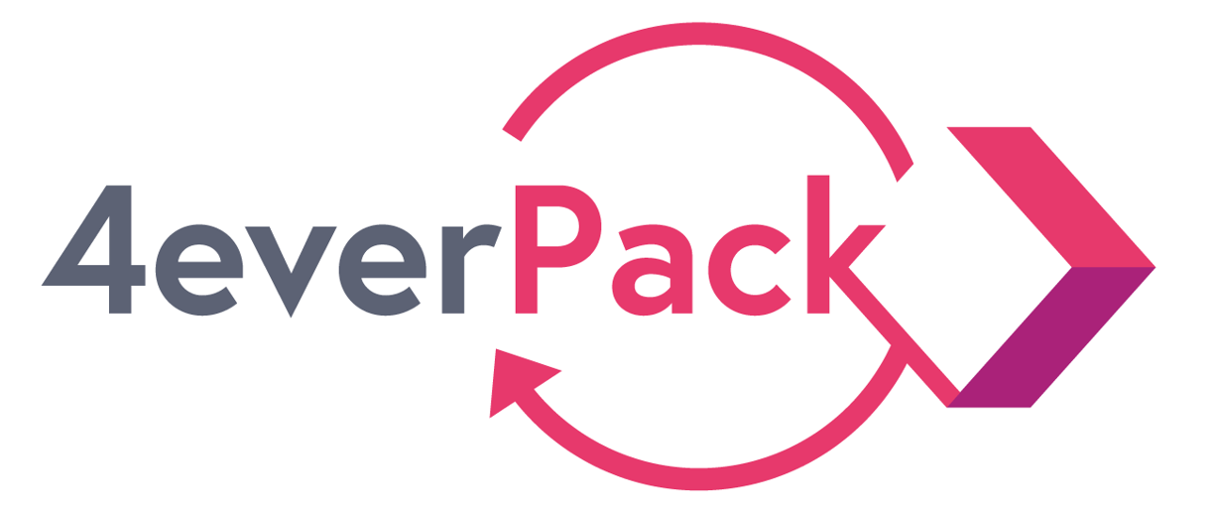

Interview Guide for the companies

Company:
Date of the interview:
Name of the interviewee:
Contact:

Introduction

The objective of this interview is to gather general information on your initial business idea related to the reusable packaging. We are interested in the motivations, past experiences, visions, objectives, and general perception on how this idea could be refined, tested and implemented in the framework of the project. To that end, we would like to ask you a first set of questions. At this stage we are not yet working on the design of the future solution, we are just interested in knowing more about your intuitions and initial ideas and how they fit within your business environment. The results of the interviews will help us clarify the future interventions associated with business modelling activities part of the project, as well as provide insights on the possible future tasks in other work packages (material, logistics, IT, consumer acceptance, etc..).

Note: ask to record the interview

Questions:

Background of the idea and business potential

Given the company pitch at the first workshop, we would like you to elaborate a bit more the background of the pitch/idea.

- Can you describe in a couple of sentences the objectives of the idea and the intended benefits associated with it? In other words, can you describe the WHY, the WHAT and the WHO FOR of this idea?

- How was this idea initially developed? Have you been thinking about it internally for quite some time or is it totally new?

- What are your drivers for innovating a novel model for reusable packaging? Why

- How strategically important is this business idea? Does it fit within a wider set of sustainability/circular economy initiatives?

- What are the potential benefits for your company, who are the potential actors benefitting and how are the benefits realized?

- What is the role of regulation? Is it a driver or a barrier? What should be done so that regulation would enable and provide incentives for reusable packaging?

- How do you plan to protect the innovations related to reusable packaging?

- How many resources/how much time could be allocated to this idea in the coming year?

- Have you been doing past projects/pilots similar to this idea? If so, can you explain a bit more? What have you learnt? Were there any barriers/issues that prevented you from moving forward?

- Ideally, what would be your vision of success in this project? What exactly would need to be achieved?

Value chain:

- What is the initial situation of the value chain that you want to adapt if your idea was to be implemented?
  - Who are the key existing stakeholders, what are their current roles? (Suppliers, users, intermediaries).
  - What is currently not working? Where in the value chain is the main issue?

- What are the key aspects of the value chain that would need to change if you were to implement this idea?
  - Which new actors would need to be involved?
  - Could some existing actors be still involved but would need to change some of their activities?

- What are the benefits and costs for each actor in the value-chain? And how to divide them among the partners?

- What are the barriers for each actor in the value-chain?

- What actors are missing from the value-chain? A need for totally new type of actors?

Collaboration and partnerships:

- When looking at the list of consortium members and their initial ideas, can you identify some companies with whom you could see strong synergies?

- Are there potential other companies outside the consortium that are central to the topic?

- More precisely
  - Material innovation actors: which company would you see yourself collaborate with?
  - Logistics actors?
  - IT actors

Barriers:

- At first glance, what kind of challenges do you foresee if this idea was to be implemented?
  - Material challenge?
  - Logistics challenge?
  - IT challenge?
  - Consumer acceptance challenge?
  - Profit/loss challenges?

Benchmark/inspiration

- Are you aware of similar examples in your industry from which we could build upon?

User/consumer experiments

- In the coming months, we might want to test your initial idea further, in some rapid experiments. What kind of resourcing/commitment your organization would provide for such activity?

AOB

- At this stage, do you have any other comments, suggestions, key points you would like to share with us?
- Would you recommend us to talk to other colleagues/partners of your organisation to gain additional knowledge on the initial idea?

